# ASSIGNMENT OF

**BCA-107**

**(Web-Technology)**

**BACHELOR OF COMPUTER APPLICATION**

**Academic Session:- 2021-22(ODD) Batch-2021-24**



**Submitted To:- Submitted By:-**

**Dr, SONAL DAHIYA Name:- Shehbaz**

**ASSISTANT PROFESSOR Enrolment No:- 2021**

**Programme:-BCA**

**Semester:-1**

 **Shift:- 1st**

**Division: A**

|  |
| --- |
|  |

|  |  |  |  |
| --- | --- | --- | --- |
| List of Practical’s of websites using HTML,CSS | | | |
| S. No. | Detailed Statement of programs |  |  |
| Core Practical’s | | | |
| 1 | Make following five different web pages:   1. Formatting Styles and Headings: Include Bold, italics, Underline, Strike, Subscript, superscript and all six type of headings 2. ii. Font Styles and Image tag 3. iii. Marquee: Move text, image and hyperlink 4. iv. Other tags: br, hr, pre, p Include following specifications: 5. ● In all these web pages only mention about use, attributes apply them. 6. ● Insert a background image on home page 7. ● Make all the topics as hyperlinks and go to some other page for description 8. ● Insert a marquee showing HTML Tutorial as moving text.   ● Use different font style for different topics  ● On every page, make a hyperlink for going back to home page and internal link also. |  |  |
| 2 | Create an unordered list nested inside ordered list and apply the following :  ● Insert an image of Main item on top right corner of web page.  ● Display heading as a marquee.  ● Use different font styles and colors for different ordered list items.  ● Insert horizontal line after each ordered item. |  |  |
| 3 | Design a table with row span and column span and make use of attributes colspan, rowspan, width, height, cellpadding, cellspacing etc. |  |  |
| 4 | Design following frame:   |  |  | | --- | --- | | MAIN MENU  Topic 1  Topic 2  Topic 3 | Explanation  - - - - - - - - - - -  - - - - - - - - - - -  View | | Example |   . |  |  |
| 5 | Make an image map showing the usage of shape, coords, href attributes in map definition. Link each hotspot to their respective details. All the web pages should be designed with proper background color, images, font styles and headings. |  |  |
| 6 | Design Student registration form for admission in college. |  |  |
| 7 | Create a webpage and show the usage of inline and internal style sheet and external style sheet? |  |  |
| 8 | Create a webpage containing a background image and apply all the background styling attributes? |  |  |
| 9 | Create a web page showing the usage of font styling attributes |  |  |
| 10 | Create a web page and apply all Text styling attributes use Id and class selector. |  |  |
| 11 | Create a webpage and implement all list styling attributes. |  |  |
| 12 | Create a Webpage with three equal columns. |  |  |
| 13 | Create a webpage containing bootstrap table. |  |  |
| 14 | Create a webpage containing various types of images. |  |  |
| 15 | Create a webpage containing various types of buttons. |  |  |
| 16 | Create a webpage containing various, typography classes. |  |  |
| 17 | Create a webpage containing to display the heading using. Jumbotron and Glyphicons. |  |  |
| 18 | Write a program to show the usage of inbuilt functions and dialog boxes. |  |  |
| 19 | Write a program to show the usage of alert box and confirm box. |  |  |
| 20 | Write a program to implement event handling using onclick, onmouseover and onmouseout events. |  |  |
| 21 | Write a program to show the usage of all the date, math and string object functions |  |  |
| 22 | WAP to display the bookstore details in XML with CSS and internal DTD. |  |  |
| 23 | WAP to format the Teacher details in XML with CSS using external DTD |  |  |
| 24 | Design the registration form for a web site and when the user clicks on submit button the login form should be appeared on the screen (use external javascript file). |  |  |
| 25 | Design a website and apply all the features of HTML, css, javascript and bootstrap to make the website attractive. |  |  |
| 26 | Write a JavaScript function that creates a table, accept row, column numbers from the user, and input row-column number as content (e.g. Row-0 Column-0) of a cell. |  |  |
| 27 | Zebra-striped Tables: Setting different background colors for alternate rows is a popular technique to improve the readability of tables that has large amount of data. This is commonly known as zebra-striping a table. Make use of pseudo classes to create zebra stripped Table. |  |  |
| 28 | Create a Questionnaire related to any topic of your choice by using Form Elements. |  |  |

Make following five different web pages:

1. Formatting Styles and Headings: Include Bold, italics, Underline, Strike, Subscript, superscript and all six type of headings
2. Font Styles and Image tag
3. Marquee: Move text, image and hyperlink
4. iv. Other tags: br, hr, pre, p Include following specifications: ● In all these web pages only mention about use, attributes apply them. ● Insert a background image on home page ● Make all the topics as hyperlinks and go to some other page for description ● Insert a marquee showing HTML Tutorial as moving text. ● Use different font style for different topics ● On every page, make a hyperlink for going back to home page and internal link also.

***HOME website page image***

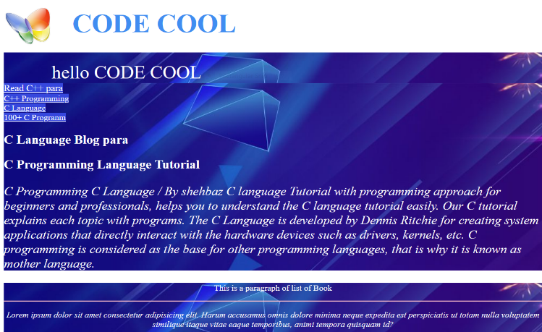

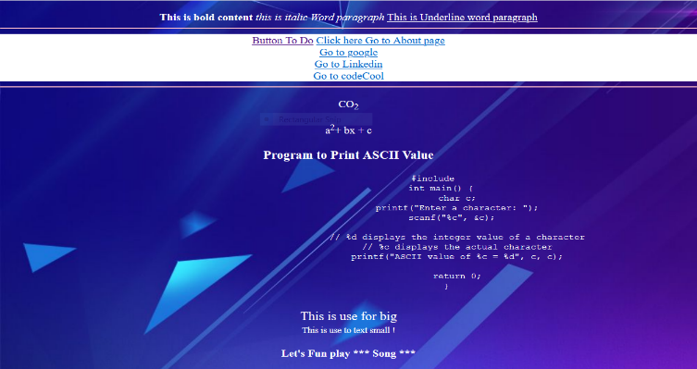

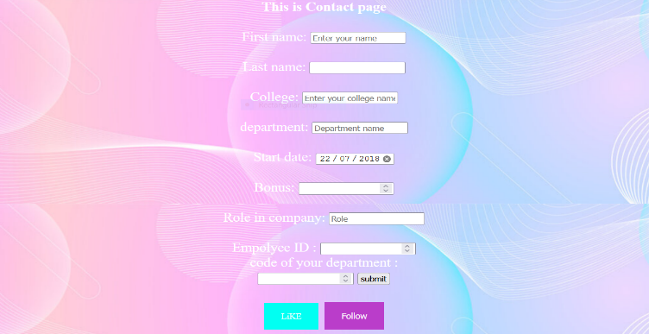

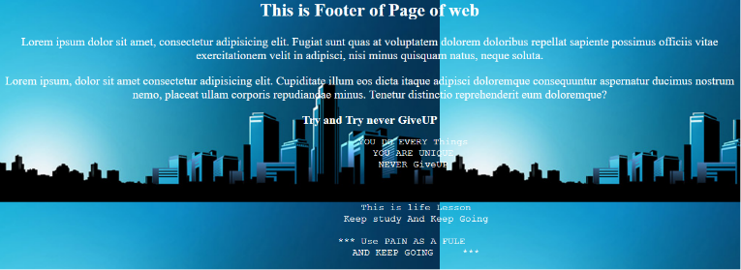

***Practical-1 webpage-1***

<!DOCTYPE html>

<html>

<head>

    <title>P1 page1 Web</title>

    <style>

        body{

            border: 5px solid rgb(0, 204, 255);

            color: black;

            font-family: Verdana, Geneva, Tahoma, sans-serif;

        }

    </style>

</head>

<body>

    <h1>hello this is Page</h1>

    <p><h2>C++ Programming</h2>

      <u>  C++ tutorial provides basic and advanced concepts of C++. Our C++ tutorial is designed for

        beginners and professionals. </u>

       <i> C++ is an object-oriented programming language. It is an extension to C programming. </i>

       <h3> C++ Standard Libraries </h3>

       <h4> Usage of C++ </h4> By the help

            Embedded firmware etc

        C++ Program

      <p>Formul of chemistry H<sub>2</sub>O</p>

      <p>Formul of chemistry C<sub>2</sub>O</p>

      <p>Formul of chemistry NH<sub>3</sub></p>

      <p>Formul of chemistry H<sub>2</sub>SO<sub>4</sub></p>

      <p>Formul of chemistry NH<sub>3</sub></p>

      <p>Formul of chemistry H<sup>+</sup></p>

      <p>Formul of chemistry co<sub>2</sub><sup>-</sup></p>

      <s> In this tutorial, all C++ programs are given with C++ compiler so that you can easily change the C++ program code.</s>

         </p>

</body>

</html>

***Website of p1-w1***

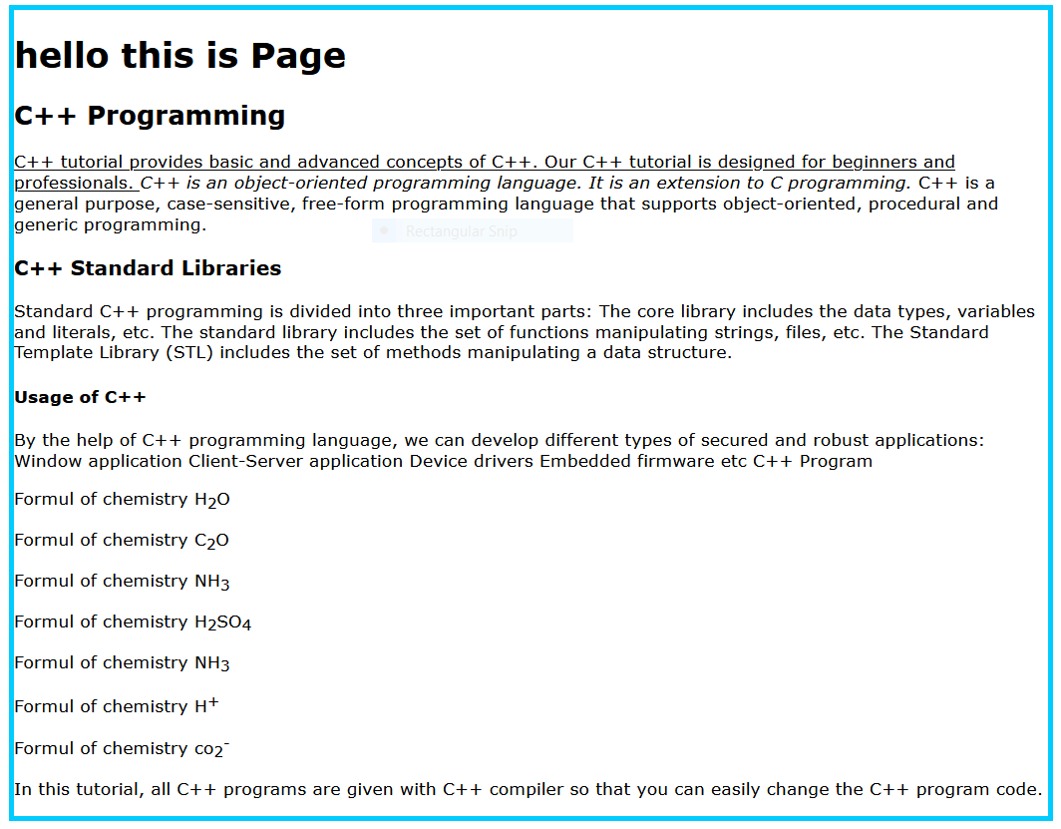

***Practical-1 webpage-2***

<!DOCTYPE html>

<html>

<head>

    <title>P1 Webpage2</title>

    <style>

        body{

            border: 5px solid rgb(0, 204, 255);

            color: black;

            font-family: Verdana, Geneva, Tahoma, sans-serif;

        }

    </style>

</head>

<body>

    <h1>CODE COOL</h1>

    <h2>Practical 1 Website page 2</h2>

    <p>Lorem ipsum dolor, sit amet Magnam rem provident, animi omnis hic ex doloribus veniam

         fugit recusandae! Veniam sint aperiam natus placeat dignissimos culpa?</i>

    </p>

    <img src="/city Girl.jfif" alt="loding" width="120px">

</body>

</html>

***Website of p1-w2***

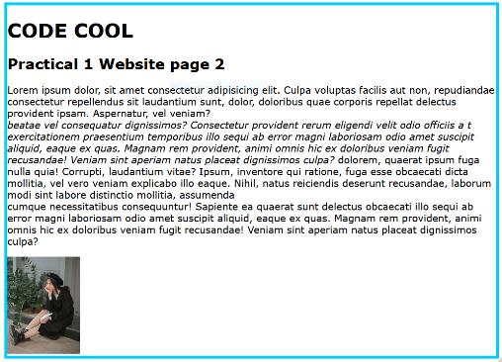

***Practical-1 webpage-3***

<!DOCTYPE html>

<html lang="en">

<head>

    <title>P1 webpage3 </title>

    <style>

        body{

            border: 5px solid rgb(0, 204, 255);

            color: black;

        }

    </style>

</head>

<body>

    <h1>CODE COOL</h1>

    <h1>Practical 1(Website Page 3) </h1>

    <marquee behavior="light" direction="right">hello CODE HUB...</marquee>

    <h3>Click Picture go to Google </h3>

    <a href="https:google.com"><img src="/city Girl.jfif" alt="loding" width="120px"></a>

</body>

</html>

***Website of p1-w3***

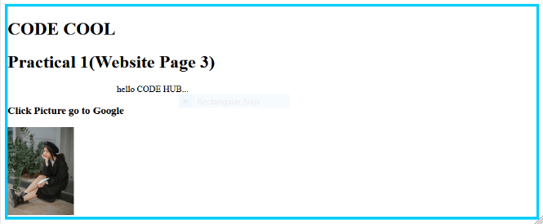

***Practical-1 webpage-4ractical-1 webpage-4***

<!DOCTYPE html>

<html>

<head>

    <title>P1 WEbpage4</title>

    <style>

        body{

            font-size: 20px;

            border: 5px solid cyan;

            color: black;

        }

    </style>

</head>

<body>

    <h1>CODE COOL</h1>

    <p> content of paragraph

        <br><hr>

        What can Python do?

            Python can be used on a server to create web applications.development.

        Example

        print("Hello, World!")</pre>

</body>

</html>

***Website of p1-w4***

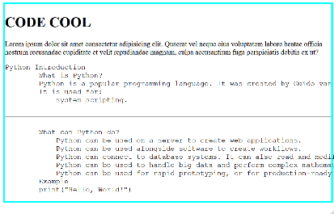

Practical-2

<!DOCTYPE html>

<html>

<head>

    <title>Nested List</title>

    <style>

        .header img{

            float: left;

            width: 90px;

            height: 90px;

        }

        .header h1{

            position: relative;

            top: 18px;

            left: 10px;

        }

        .section{

            font-family: italic;

            color: white;

            font-size: 20px;

            image-rendering: top-right;

            background-image: url("/data-original\ background\ web.jpg");

        }

</style>

    </style>

</head>

<body class="section">

    <div class="header">

        <img src="/821372194 Buterfly icon.png" alt="icon">

        <h1 > CODE COOL </h1>

    </div>

    <h3><marquee behavior="light" direction="role">hello CODE COOL</marquee></h3><br>

    <h3>Web Development</h3>

    <ul> constant in C language

        <ul>

            <li>Primary constant

                <ol>

                    <li>Integer constant</li>

                    <li>Real constant </li>

                    <li>Character constant </li>

                </ol>

            </li>

            <li>secondary constant

                <ol>

                    <li>Array</li>

<li>Pointer</li><li>structure</li><li>Union</li><li>Enum etc.</li>

                </ol>

            </li>

        </ul>

    </ul><hr>

<ul><li> Recipe of Make Tea

        <ul>Preparation Time: 2 minutes</ul>

        <ul>Cooking Time: 10 minutes</ul>

        <ul>Serves: 2 servings (2 cups)

            <ul>

                <li> Cooking Measurements    Ingredients:

                <ol>

                    <li>cup (250 ml) Milk</li>

                    <li>teaspoons Tea Powder</li>

                    <li>1/4 cup (approx. 60 ml) Water</li>

                    <li>teaspoons Sugar</li>

                </ol>

                <ul>

                    <li>Directions:

                        <ol>

                        <li> Boil water in a saucepan.</li>

                        <li>Add sugar and tea powder in it and boil it for 3-4 minutes on medium flame.</li>

                        <li>Add milk and boil it over medium flame for 6-7 minutes or until bubble starts to rise. in cups.</li>

                        </ol>

                    </li>

                </ul>

                </li>

            </ul>

        </ul>

    </li>

</ul>

<br><hr style="height: 10px;">

<section style="text-align: center;">

    <h3>Tips of Making Tea </h3>

        <pre>

            Preparation Time: 2 minutes

            Cooking Time: 10 minutes

            Serves: 2 servings (2 cups)

                Cooking Measurements

                Ingredients:

                1 cup (250 ml) Milk

                2 teaspoons Tea Powder

                1/4 cup (approx. 60 ml) Water

                3 teaspoons Sugar

                Tips and Variations:

                    If you like more creamy tea, then avoid water and use only milk. Mix milk,

                     sugar and tea powder and boil them over low flame for 6-7 minutes.

                Taste: Sweet and Hot

                Serving Ideas: Serve it in the morning with breakfast or in the afternoon with evening snacks.

                Author: shehbaz Khan

        </pre>

</section>

</body>

</html>

***Website of P2***



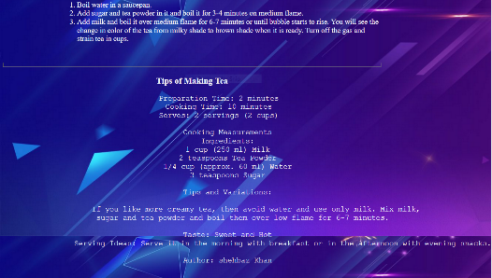

Practical-3

<!DOCTYPE html>

<html>

<head>

    <title>Table of page</title>

    <style>

        .header img{

            float: left;

            width: 90px;

            height: 90px;

        }

        .header h1{

            position: relative;

            top: 25px;

            left: 15px;

            color: white;

        }

        .table{

            color: blue;

            border: 30%;

            box-sizing: border-box;

            height: 30%;

            background-image: url("/background.webs.jpg");

        }

        .body{

            background-image: url("/data-original\ background\ web.jpg");

        }

        .div{

            background-image: url("/data-original\ background\ web.jpg");

        }

    </style>

</head>

<body class="body">

    <div class="header div">

        <img src="/821372194 Buterfly icon.png" alt="icon">

        <h1 style="font-size: 50px;"> CODE COOL </h1>

    </div><br><hr color="cyan" height="15px">

    <div>

        <h2 style="color: white; font-size: 30px;" >This is Table page</h2>

        <table class="table"  border="3",hight= "30%"  cellpadding="5">

            <thead>

                <tr>

                    <th colspan="5"> Employee Details Of My Company SK CODE </th>

                </tr>

                <th> Name of Employee </th>

                <th> Department name</th>

                <th> Department id </th>

                <th> Employee id </th>

                <th> salary </th>

            </thead>

            <tr>

                <td>hardeep</td>

                <td>CS </td>

                <td>34001</td>

                <td>Skp650</td>

                <td>55000</td>

            </tr>

            <tr>

                <td> Apj Abdul Kalam</td>

                <td>AI </td>

                <td>34001</td>

                <td>Sk150</td>

                <td>115000</td>

            </tr>

            <tr>

                <td>Akib</td>

                <td>UI</td>

                <td>34501</td>

                <td>Skp650</td>

                <td>56000</td>

            </tr>

            <tr>

                <td>kein kumar</td>

                <td>CS </td>

                <td>34201</td>

                <td>Skr650</td>

                <td>55010</td>

            </tr>

            <tr>

                <td>hardeep</td>

                <td>CS </td>

                <td>34001</td>

                <td>Ssp650</td>

                <td>51500</td>

            </tr>

        </table>

    </div><hr>

    <div>

        <table  class="table"  border="3",hight= "30%" cellspacing="5" cellpadding="5">

            <thead>

                <tr><th colspan="5">** WAR GAME **</th></tr>

            <tr>

                <th>s.no</th><th>Player name</th><th>Max score kills</th><th>Game</th>

            </tr>

            <tr>

                <td>1</td><td>sachin</td><td>600</td><td>Pubg</td>

            </tr>

        </thead>

            <tr>

                <td>2</td><td>keen kumar</td><td>230</td><td>freefire</td>

            </tr>

            <tr>

                <td>3</td><td>virat kholi</td><td>270</td><td>freefire</td>

            </tr>

            <tr>

                <td>4</td><td>Bipin Rawat</td><td>10001</td><td>fuaG</td>

            </tr>

        </table>

    </div>

<br> <hr color="blue" height="5px">

    <div>

        <table style="width: 40%; color: black;background-image: url(/background.webs.jpg); border: 3px solid rgb(202, 255, 117);"border="3" hight= "30%" cellspacing="5"  >

            <thead>

                <th>Name </th>

                <th>Roll no </th>

                <th>class </th>

            </thead>

            <tr>

            <td> javed</td><td> 12</td><td> 12th</td></tr>

<tr>

            <td>shehbaz</td><td> 13</td><td> 10th</td>

</tr>

<tr>

            <td> shehbazpro</td><td> 14</td><td> 11th</td>

</tr>

        </table>

    </div>

</body></html>

***Website of P3***

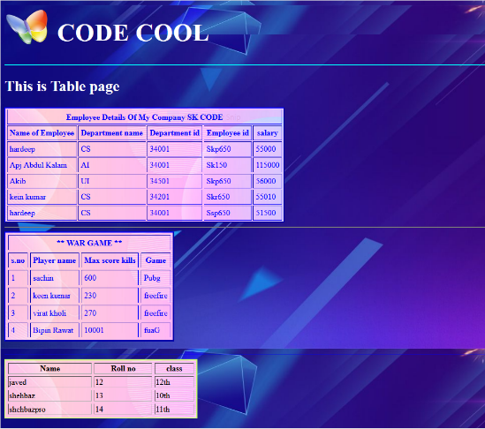

Practical-4

<!DOCTYPE html>

<html>

<head>

    <title>hello frames</title>

    <link rel="icon" href="/821372194 Buterfly icon.png" type="icon">

    <frameset  cols="*,*">

            <frame src="index.html">

            <frameset rows=" * , * ">

                <frame src="/P2.html">

                <frame src="/pragraph_C.html">

                <!-- <frame src="C++para.html"> -->

            </frameset>

    </frameset>

</head>

</html>

***Website of P4***

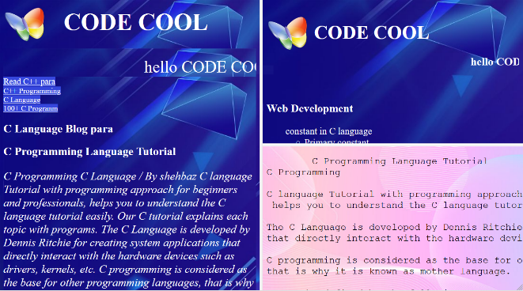

Practical-5

<!DOCTYPE html>

<html>

<body>

<h1>CODE COOL</h1>

<h2>Image Maps</h2>

<p>Click on the computer or Book to go to a new page and read more about the topic:</p>

<img src="/computer video conference.png" alt="Workplace" usemap="#workmap" width="600px" height="302">

<map name="workmap">

  <area shape="rect" coords="127,5,480,235" alt="Computer" href="/computer_info.html">

  <area shape="rect" coords="508,171,583,300" alt="Book" href="/Book.html">

  <!-- <area shape="circle" coords="337,300,44" alt="Cup of coffee" href="coffee.htm"> -->

</map>

</body>

</html>

***Website of P5***

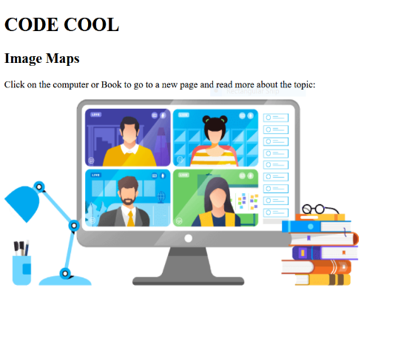

***When we Click on computer***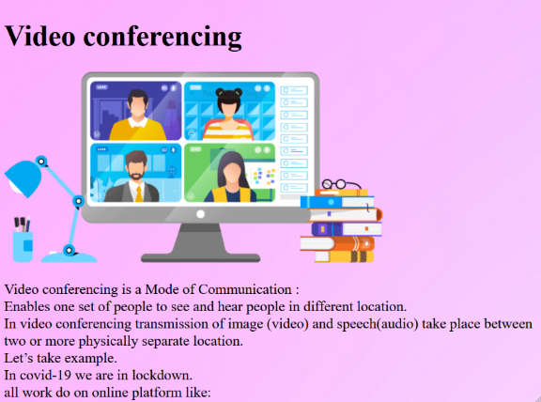

***when we click on Book***

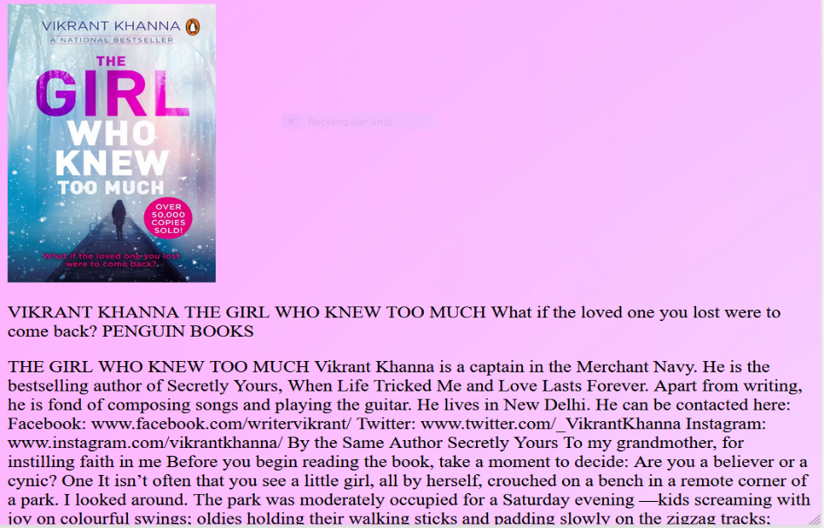

Practical-6

<!DOCTYPE html>

<html lang="en">

<head>

    <meta charset="UTF-8">

    <meta http-equiv="X-UA-Compatible" content="IE=edge">

    <meta name="viewport" content="width=device-width, initial-scale=1.0">

    <title>college form</title>

    <style>

        .button {

        border: none;

        color: white;

        padding: 15px 32px;

        text-align: center;

        text-decoration: none;

        display: inline-block;

        font-size: 16px;

        margin: 4px 2px;

        cursor: pointer;

        }

        .button1 {background-color: #4CAF50;} /* Green */

        .button2 {background-color: #008CBA;} /* Blue */

        .body{

            background-image: url("/data-original\ background\ web.jpg");

        }

        .form{

            color: white;

            font-size: 22px;

            text-align: center;

            height: 1046px;

            margin: 15px 200px 200px 200px;

            font-family: italic;

            page-break-inside: inherit;

            background-image: url("/data-original\ background\ web.jpg");

        }

        .header img{

            float: left;

            width: 90px;

            height: 90px;

        }

        .header h1{

            position: relative;

            top: -1px;

            left: 105px;

          }

    </style>

</head>

<body class="body">

    <div class="header">

        <img src="/821372194 Buterfly icon.png" alt="icon">

        <h1 style="background-image: url(/programmer-fix-problem-purple-background.jpg); width: 1413.2px; height: 85.6px; font-size: 70px;margin: 0px 0px 0px 0px; color: white;">CODE COOL</h1>

    </div>

    <section style="background-image: url(/background.webs.jpg);">

        <form class="form">

            <h1>registration form for admission in college</h1><br><br>

            <label for="fname">First name: </label>

            <input type="text" placeholder="Enter your name" id="fname" name="fname" width="30px" height="30px"><br><br>

            <label for="lname">Last name: </label>

            <input type="text" id="lname" name="lname"><br><br>

            <label for="Father">Father name: </label>

            <input type="text" id="father" name="father"><br><br>

            <label for="Age">  Your Age: </label>

            <input type="number" name="myAge" id="Age"><br><br>

            <label for="lcollege">College:</label>

            <input type="text" placeholder="Enter your college name" id="lcollege" name="lcollege"><br><br>

            <label for="studentID">Student ID:</label>

            <input type="number" id="studentID" name="StudentID"><br><br>

            <label for="department">department:  </label>

            <input type="text"  placeholder="Department name" id="department" name="department"> <br><br>

            <label for="DOB">DOB: </label>

            <input type="date" id="DOB" name="trip-start" value="2018-07-22" min="1900-01-01" max="2022-12-31"><br><br>

            <label for="courses">courses : </label>

            <input type="checkbox" >BCA

                 <input type="checkbox" >MCA

                 <input type="checkbox" >bjmca <br><br>

                 <label for="gender">Gender: </label>

                 <input type="radio" name="gender" > Male

                 <input type="radio" name="gender" > Female

                 <input type="radio" name="gender" > Other  <br>

                 <label for="Shift">Shift : </label>

                 <input type="radio" name="Shift" > Morning Shift

                 <input type="radio" name="Shift" > Evening Shift <br><br>

                 <label for="state">Enter Your State:</label>

                 <input list="state" name="state" id="state"><br><br>

               <!-- <label for="state" name="up" id="up"> Enter your State: </label>

             state: <select name="up" id="up">

             </pre>

              <br>

            <button class="button button1">LiKE</button> -->

            <label for="College ID "> College ID :</label> <input type="number" name="mycollegeID" id="College ID"><br><br>

            <label for="mob"> Mobile no : </label> <input type="number" name="mymob" id="mob"><br><br>

            <label for="email">Enter Your Email id </label> <input type="email" id="email" name="email"><br>

            <button onClick="location.href='/submit.html'" type="button" style=" width: 85px; height: 34px; font-size: 18px;  background-color: rgb(245, 245, 247);">submit</button><br><br>

            <a href="/Like.html" type="button" class="button button1" target="_blank">LiKE</a> <button class="button button2">Follow</button>

            <!-- <label for="email"></label><br> -->

        </form>

        <br><hr>

        <div style="align-self: center;">

            <h2 style="color: white; ">    Leave your Comment  </h2>

            <textarea style="width: 639px; height: 183px;" placeholder="Enter your comment" ></textarea><br>

            <a href="/Like.html" type="button" class="button button1" target="_blank">Submit</a>

        </div>

    </section>

</body>

</html>

***Website of P6***

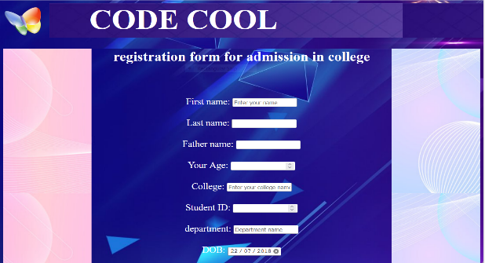

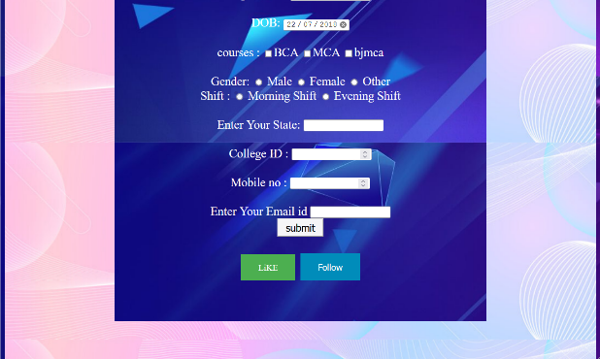

Practical-7

<!DOCTYPE html>

<html>

<head>

    <title>Practical 7 </title>

    <link rel="stylesheet" href="/style1.css">

    <style>

        body{

            color:rgb(0, 4, 255);

            background-image: url(/jrLO3S\ Background\ image.jpg);

            font-size: 23px;

        }

    </style>

</head>

<body>

    <h1 style="color: rgb(255, 0, 157);">Video conferencing</h1>

    <img src="/computer video conference.png" alt="loging" style="align-self: center;">

    <h2>CSS use of (inline and internal style sheet and external style sheet) </h2>

    <p>

                Video conferencing is a Mode of Communication : <br>

        Enables one set of people to see and hear people in different location. <br>

        In video conferencing transmission of image (video) and speech(audio) take place between two or more physically separate location. <br>

        Let’s take example. <br>

        In covid-19 we are in lockdown. <br>

        all work do on online platform like: <br>

        Conference/seminar/project work etc… <br>

        Study do online with videoconferencing and face-to-face meetings. <br>

    </p>

</body>

</html>

***Website of P7***

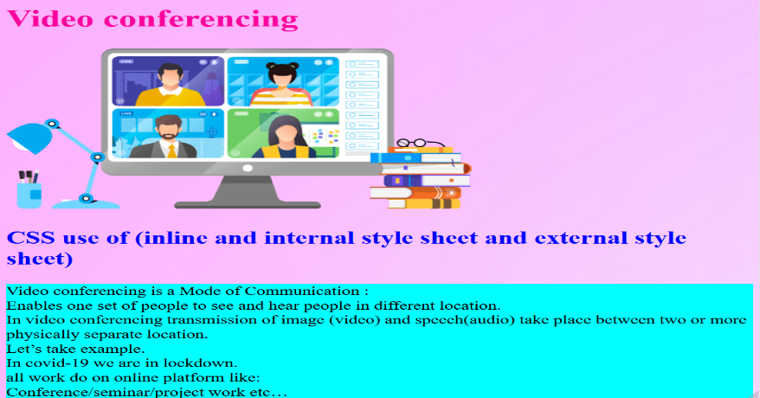

Practical-8

<!DOCTYPE html>

<html>

<head>

    <title>CSS background-image </title>

    <style>

        .p{

            background-image: url(/jrLO3S\ Background\ image.jpg);

            background-size: 400px;

            border: 3px solid red;

            width: 720px;

            color: blue;

            background-attachment: fixed;

            background-position: center;

        }

        .body{

            color: rgb(28, 25, 235);

            background-image:  url(/jrLO3S\ Background\ image.jpg);

            background-size: 1500px;

            /* width: 500px; */

            background-repeat: repeat;

            backface-visibility: visible;

            background-attachment: fixed;

            background-blend-mode: overlay;

            background-blend-mode: hard-light;

            background-repeat: repeat-x;

            background-position-x: center;

            font-size: 20px;

        }

    </style>

</head>

<body class="body">

        <h1 style="color: white; background-color:  #40cae0; text-align: center; font-size: 45px;border: 3px solid rgb(0, 255, 112);">CODE COOL</h1>

        <h2>containing a background image and apply all the background styling attributes?</h2>

    <p> <p>VERBAL AND NON-VERBAL COMMUNICATION </p>

        <p>

            Verbal communication is the use of auditory language to exchange information

            with other people. It includes sounds, words, or speaking. The tone, volume, and

            pitch of one's voice can all contribute to effective verbal communication.

            It is the most effective form of communication that leads to the rapid interchange

            of information and feedback. There are fewer chances of misunderstanding as the

            communication between parties is clear, i.e. the parties are using words anything.

        </p> <p>

in which the sender follows a pre- defined channel

            to transmit the information to the receiver is known as formal

            communication.</p><p>

the information is known as informal communication.

            Non-verbal communication</p>

        <p class="p">Lorem ipsum dolor sit amet consectetur adipisicing elit. Possimus non veritatis a aperiam? esse

sit amet estias aliquam voluptatem nesciunt officiis tenetur ducimus a impedit incidunt perspiciatis nihil nisi quaerat! Quibusdam obcaecati perferendis quos quidem! </p>

</body>

</html>

***Website of P8***

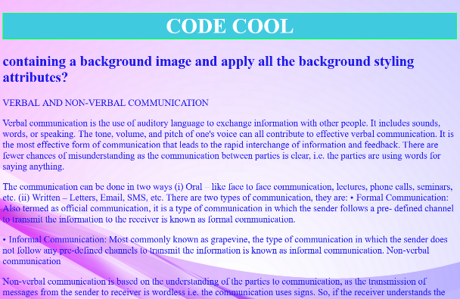

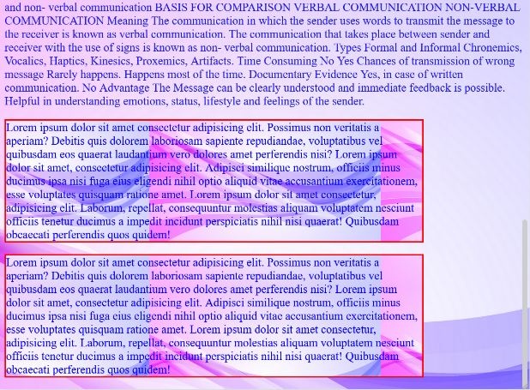

Practical-9

<!DOCTYPE html>

<html lang="en">

<head>

    <title>font styling attributes</title>

    <style>

        .body{

            font-size: 1.1em;

            /* font-family: Verdana, Geneva, Tahoma, sans-serif; */

            font-family: 'Architects Daughter', cursive;

            font-display: 80%;

            font: optional;

            font-variant: no-common-ligatures proportional-nums;

            font-feature-settings: "tnum";

            font-weight: bolder;

            background-image: url(/website-background-wallpaper1-jpg_2560x1600_h.jpg);

            background-attachment: fixed;

            color: white;

        }

        @import url('https://fonts.googleapis.com/css2?family=Architects+Daughter&display=swap');

        @font-face {

   font-family: myFirstFont;

   src: url(sansation_light.woff);

}

.div1{

    font-style: oblique;

    font-size: 25px;

    color: rgb(17, 0, 255);

}

@font-face {

   font-family: myFirstFont;

   src: url(sansation_bold.woff);

   font-weight: bold;

}

* {

   font-family: myFirstFont;

}

    </style>

</head>

<body class="body">

    <h1 style="color: rgb(218, 9, 245);font-weight: bolder;font-size: 43px; text-align: center;

    background-color: rgb(154, 245, 9); border: 3px solid cyan;">CODE COOL</h1>

    <h1 style="color: rgb(154, 245, 9);font-weight: bolder;">web page showing the usage of font styling attributes</h1>

    <p>

 <p>

    <h2>IBM Watson Studio</h2>

 </p>

<p>

    Build and scale trusted AI on any cloud. Automate the AI lifecycle for ModelOps.

    Try on cloud at no cost

    Book a meeting

</p>

<p>

    See product documentation

    IBM named a Leader

</p>

<p><i>

    Gartner releases 2021 Magic Quadrant for Data Science and Machine Learning Platforms.

    Get the report

    Bring AI models to production

    Scale AI across any cloud</i>

</p>

<p><font face = "cursive" style="color: rgb(65, 236, 228);">

    IBM Watson® Studio empowers data scientists, developers and analysts to build,

    run and manage AI models, and optimize decisions anywhere on IBM Cloud Pak® for Data.

     Unite teams, automate

     AI lifecycles and speed time to value on an open multicloud architecture.

    </font>

</p>

<p> <font size="4" style="color: cyan;">

     Bring together open source frameworks like PyTorch, TensorFlow and scikit-learn with IBM

     and its ecosystem tools for code-based and visual data science. Work with Jupyter notebooks,

     JupyterLab and CLIs — or in languages such as Python, R and Scala.

    </font>

</p>

<h1>The @font-face Rule</h1>

<div>

With CSS, websites can use <b>fonts other than the pre-selected "web-safe" fonts</b>.

</div>

<div style="color: rgb(154, 245, 9);">

    <p>

        Get started

        Build AI models with IBM Watson Studio

        Build AI models with IBM Watson Studio (01:13)

        How it’s used

    </p>

    <pre>

        Implement explainable AI

        Optimize decisions

        Develop models visually

        Build ModelOps

        Speed AI development with AutoAI

    </pre>

</div>

<div1 class="div1">

    <p>

        Business professional in an office working on laptop

        Implement explainable AI

    </p>

    <p>

        Explainable AI is a set of processes and methods that allows human users to

        comprehend and trust the results and output created by AI algorithms,

        including its expected impact and potential biases.

    </p>

    <pre>

        Learn more about explainable AI

        Flexible options

        Build models where your data lives

        Deploy on any cloud

        On IBM Cloud Pak for Data

    </pre>

    Run Watson Studio on your own hybrid cloud using a unified data and AI platform.

</div1>

    </p>

</body>

</html>

***Website of P9***

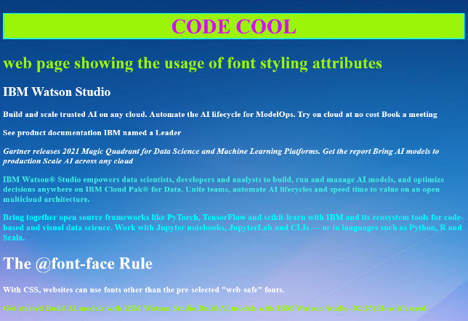

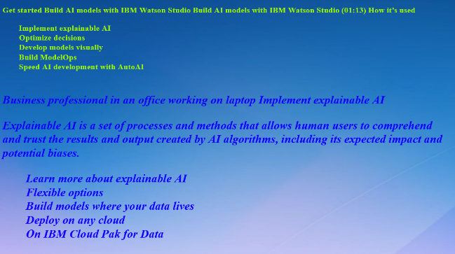

Practical-10

<!DOCTYPE html>

<html>

<head>

    <title>CSS Text styling attributes </title>

    <style>

        .body{

            text-align: justify;

            text-decoration: none;

            text-shadow: rgb(0, 132, 255);

            text-anchor: inherit;

            text-transform: lowercase;

            text-emphasis: 15px;

            text-align-last: center;

            text-emphasis: none;

            text-emphasis-style: initial;

            text-emphasis-color:rgb(49, 112, 248);

            border: 5px solid rgb(0, 68, 255);

            font-size: 27px;

            font-style: italic;

            content: inherit;

            color: red;

        }

        #p{

            color: blue;

            text-emphasis-style: 20px;

            text-decoration: rgb(253, 0, 0) wavy underline;

            font-family: monospace;

        }

        p{

            color: rgb(255, 0, 0);

            font-weight: lighter;

            font-style: initial;

            text-decoration: lawngreen;

        }

        </style>

</head>

<body class="body">

    <h1 style="font-weight: bold;text-align: center;text-shadow: blue;

    text-indent: 40px; color: rgb(55, 247, 17);background-color: rgb(250, 7, 209);border: 4px solid cyan;">CODE COOL</h1>

    <h2>Create a web page and apply all Text styling attributes use Id and class selector.</h2>

    <img src="/the-girl-who-knew-too-much-original-image.webp" alt="loging"width="220px",

    style="background-repeat: repeat-x;">

    <img src="/the-girl-who-knew-too-much-original-image.webp" alt="loging"width="220px",

    style="background-repeat: repeat-x;">

    <img src="/the-girl-who-knew-too-much-original-image.webp" alt="loging"width="220px",

    style="background-repeat: repeat-x;">

    <p id="p">apply all Text styling attributes use Id and class selector.

         VIKRANT KHANNA THE GIRL WHO KNEW TOO MUCH What if the loved one you lost were to come back?

         PENGUIN BOOKS

         THE GIRL WHO KNEW TOO MUCH Vikrant Khanna is a captain in the Merchant Navy.

          By the Same Author Secretly Yours

        To my grandmother, for instilling faith in me

    </p>

    <p> HTML Tutorial

        HTML tutorial

    </p>

    <p>

       <i>

        HTML tutorial or HTML 5 tutorial provides basic and advanced concepts of HTML. Our HTML

          you will be able to create your own interactive and dynamic website.

          But Now We will focus on HTML only in this tutorial.</i>

    </p>

     <p style="text-align-last: center;font-family: cursive;">

         The major points of HTML are given below:

             HTML stands for HyperText Markup Language.

             HTML is used to create web pages and web applications. </p>

        <p>

        HTML Example with HTML Editor

         with our online HTML editor. Learning HTML is fun, and it's very easy to learn.

        </p>

</body>

</html>

***Website of P10***

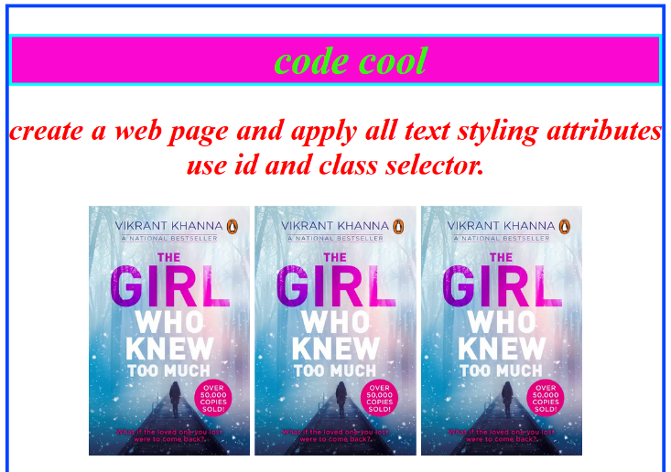

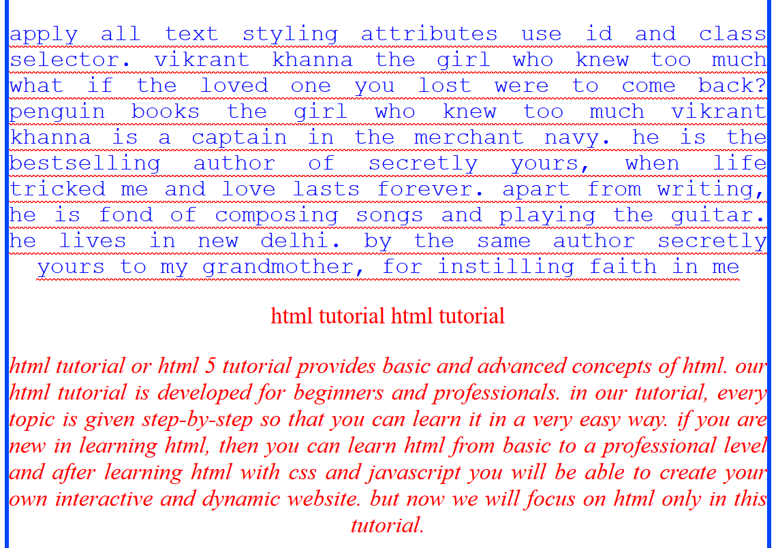

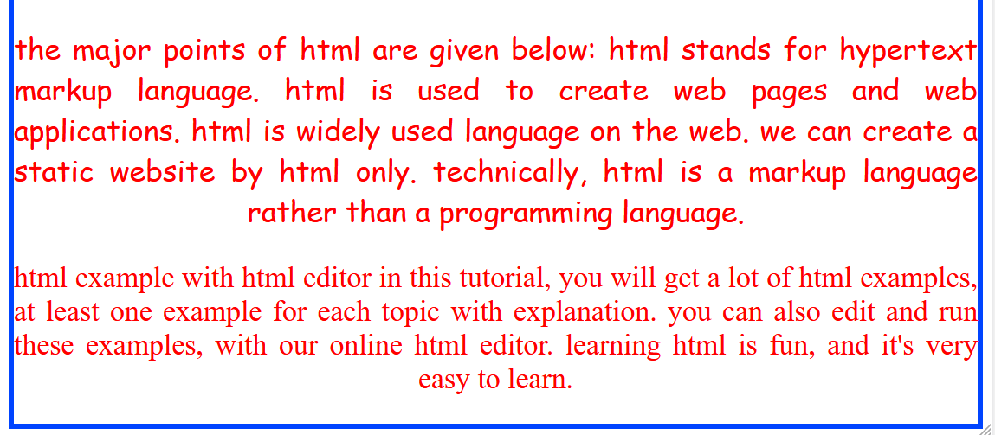

Practical-11

<!DOCTYPE html>

<html>

<head>

    <title>P-11 </title>

    <link rel="stylesheet" href="/style.css">

    <style>

        div{

            color: blue;

            background-color: cyan;

        }

        ol{

            font-family: cursive;

            line-height: 18px;

            list-style-type: square;

        }

        ul{

            font-family: cursive;

            line-height: 18px;

            list-style-type: disc;

            list-style-position: outside;

        }

        .body{

            color: white;

            list-style: initial;

            line-height: 25px;

            list-style-position: inside;

            line-height-step: 30px;

            list-style-type: disc;

            border: 5px solid cyan;

            background-color: rgb(243, 44, 210);

        }

    </style>

</head>

<body class="body" style="border: 5px solid cyan;">

    <h1 style="text-align: center;">CODE COOL</h1>

    <p> implement all list styling attributes.</p>

     <p>    IBM Watson Studio

       Build and scale trusted AI on any cloud. Automate the AI lifecycle for ModelOps.

       Try on cloud at no cost

       Book a meeting

    <div class="body">

    <h3>Web Development</h3>

    <ul> constant in C language

        <ul>

            <li>Primary constant

                <ol>

                    <li>Integer constant</li>

                    <li>Real constant </li>

                    <li>Character constant </li>

                </ol>

            </li>

            <li>secondary constant

                <ol>

                    <li>Array</li>

<li>Pointer</li><li>structure</li><li>Union</li><li>Enum etc.</li>

                </ol>

            </li></ul></ul><hr>

<ul style="list-style: georgian;list-style-type: lower-greek;list-style-position: outside;"><li> Recipe of Make Tea

        <ul>Preparation Time: 2 minutes</ul>

        <ul>Cooking Time: 10 minutes</ul>

        <ul>Serves: 2 servings (2 cups)

            <ul>

                <li> Cooking Measurements    Ingredients:

                <ol>

                    <li>cup (250 ml) Milk</li>

                    <li>teaspoons Tea Powder</li>

                    <li>1/4 cup (approx. 60 ml) Water</li>

                    <li>teaspoons Sugar</li>

                </ol>

                <ul>

                    <li>Directions:

                        <ol>

                        <li> Boil water in a saucepan.</li>

                        <li>Add sugar and tea powder in it and boil it for 3-4 minutes on medium flame.</li>

                        <li>Add milk and boil it over medium flame for 6-7 minutes or until bubble starts to rise.

                        You will see the change in color of the tea from milky shade to brown shade when it is ready.

                        Turn off the gas and strain tea in cups.</li>

                        </ol>

                    </li>

         </ul></li></ul></ul></li></ul>

<br><hr style="height: 10px;">

       </div>

       Bring AI models to production

       Scale AI across any cloud

       <div style="font-size: 25px;">

           <ul type="square">

               <li>Hello</li><li>More</li><li>About</li><li>Code</li>

               <ol type="a">

                   <li>Hello</li><li>More</li><li>About</li><li>Code</li>

                </ol>

                <li>Decode</li><li>code hub</li>

            </ul>

</div></p></body></html>

***Website of P11***

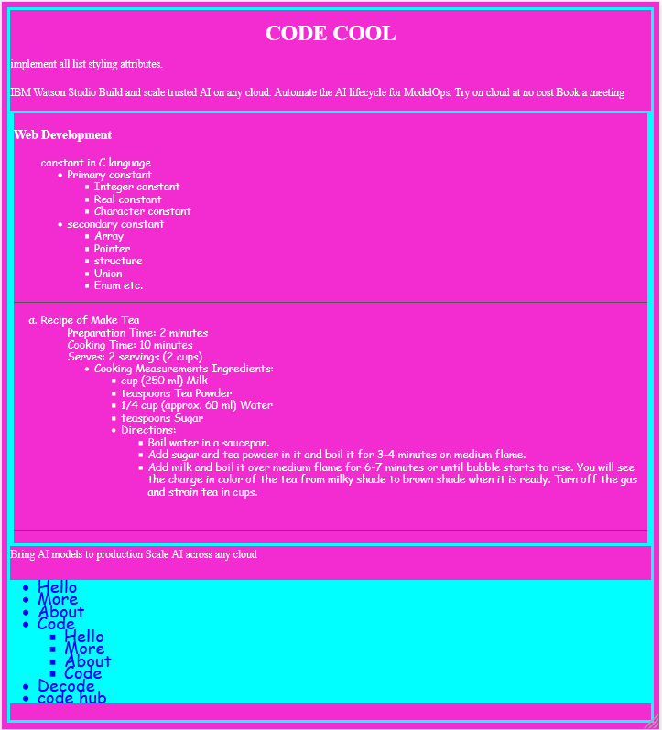

Practical-12

<!DOCTYPE html>

<html>

<head>

  <title>Bootstrap Example three Equal columns</title>

  <meta charset="utf-8">

  <meta name="viewport" content="width=device-width, initial-scale=1">

  <link rel="stylesheet" href="https://maxcdn.bootstrapcdn.com/bootstrap/3.4.1/css/bootstrap.min.css">

  <script src="https://ajax.googleapis.com/ajax/libs/jquery/3.5.1/jquery.min.js"></script>

  <script src="https://maxcdn.bootstrapcdn.com/bootstrap/3.4.1/js/bootstrap.min.js"></script>

</head>

<body>

<div class="container-fluid">

  <div style="background-color: rgb(0, 204, 255); margin: 0px;padding: 0px;">

    <h1 style="text-align: center; color: blue;">National Flag</h1>

    <p style="color: rgb(243, 12, 185);font-size: 20px; ">The National Flag is a horizontal tricolour of India saffron (kesaria) at the top, white in the middle and India green at the bottom in equal proportion.p>

  </div>

  <div class="row">

    <div class="col-sm-4" style="background-color:rgb(240, 113, 9); height: 640px; font-size: 20px;  border: 3px solid white; border-radius: 5px;">

        <br>Quick Facts about India

        <br>The Flag of India

        <br> flagIndia lies in south Asia, between Pakistan, China and Nepal. To the north it is bordered by the world's highest mountain chain.

        </div>

    <div class="col-sm-4" style="background-color:rgb(255, 254, 254);height: 640px;  border: 3px solid white;border-radius: 5px; ">

    <img src="/istockphoto Ashoka Chakra.jpg" alt="lodoing" width="530px" style="text-align: center;"> </div>

    <div class="col-sm-4" style="background-color:rgb(9, 238, 9); height: 640px; border: 3px solid white;border-radius: 5px; font-size: 20px;">

      तिरंगे का तीन रंगों का क्या है मतलब

तिरंगा हमारी आन-शान और बलिदान का प्रतीक है। इसके नीचे हम सभी भारतवासी अपने को सुरक्षित और गौरवान्वित महसूस करते हैं।

</div></div></div></body></html>

***Website of P12***

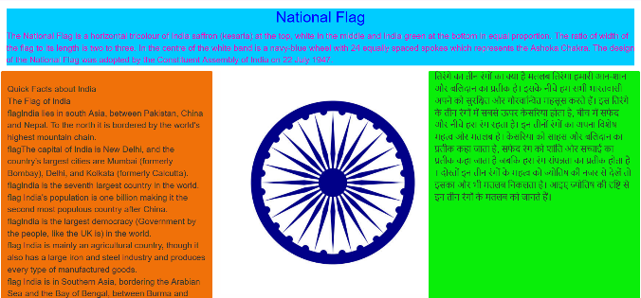

Practical-13

<!DOCTYPE html>

<html lang="en">

<head>

  <meta charset="utf-8">

  <meta name="viewport" content="width=device-width, initial-scale=1">

</head>

<body class="body" style="color: white;">

<div style="font-size: 17px; border: 3px solid cyan; color: black; text-align: center;">

  <h1> CODE COOL </h1>

  <h2>Bordered Table</h2>

  <p>A webpage containing bootstrap table.</p>

</div>

<div class="container" style="background-color: rgb(54, 54, 243); text-align: center; font-size: 15px; color: white;" >

  <table class="table table-hover table-primary table-bordered-primary">

    <thead class="thead-dark">

      <tr>

        <th colspan="5" style="text-align: center;color: white;background-color: blue; " >Details of Secret Agents</th>

      </tr>

      <tr>

        <th>Firstname</th>

        <th>Lastname</th>

        <th>Employee id</th>

        <th>JOB</th>

        <th>Email</th>

      </tr>

    </thead>

    <tbody>

      <tr>

        <td>Shehbaz</td>

        <td>Khan</td><td>Ac344</td><td>CIA Agent</td><td>mdshehbaz666@gmail.com</td>

      </tr>

      <tr>

        <td>SAM</td>

        <td>kumar</td><td>PE304</td><td>RAW Agent</td><td>samcool534@gmail.com</td>

      </tr>

      <tr>

        <td>Mary</td>

        <td>kine</td><td>AP304</td><td>isi Agent</td><td>marycool534@gmail.com</td>

      </tr>

      <tr>

        <td>Akib</td>

        <td>Khan</td><td>AP304</td><td>Mossad Agent</td><td>Ak1ibc6oo4@gmail.com</td>

      </tr>

      <tr>

        <td>kunal</td>

<td>AP304</td><td>Power Agent</td><td>kunalkumarcool534@gmail.com</td>

      </tr>

    </tbody>

  </table>

</div>

</body>

</html>

***Website of 13***

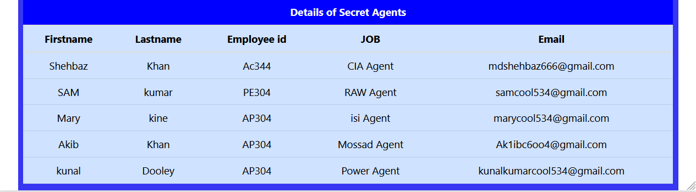

Practical-14

<!DOCTYPE html>

<html>

<head>

    <title>Bootstrap Example</title>

    <meta charset="utf-8">

    <meta name="viewport" content="width=device-width, initial-scale=1">

    <link rel="stylesheet" href="https://maxcdn.bootstrapcdn.com/bootstrap/3.4.1/css/bootstrap.min.css">

    <script src="https://ajax.googleapis.com/ajax/libs/jquery/3.5.1/jquery.min.js"></script>

    <script src="https://maxcdn.bootstrapcdn.com/bootstrap/3.4.1/js/bootstrap.min.js"></script>

    <style>

        .body{

            margin-left: 0px;

            border: 25px solid cyan;

        }

    </style>

</head>

<body class="body">

    <div style="text-align: center; background-color: rgb(255, 72, 0); color: white; border: 5px solid white; ">

        <h1>CODECOOL</h1>

    </div>

    <div style="border: 25px solid rgb(212, 0, 255);">

    <h2>Types of images in Bootstrap</h2>

    <p>A webpage containing various types of images.</p>

    <p>The .thumbnail class can be used to display an image gallery. </p>

    <!-- <img src="/source.unsplash.com3.jpg" class="img-fluid" alt="Responsive image">->

    <div class="container">

        <div class="row">

            <div class="col-md-4">

                <div class="thumbnail">

                    <img src="https://source.unsplash.com/300x300/?coder" width="304" height="236" alt="coder" >

                    <div class="caption">

                        <p>this is coder Page paragraph</p>

                    </div>

                </div>

            </div>

            <div class="col-md-4">

                <div class="thumbnail">

                    <img src="https://source.unsplash.com/200x200/?Technology"  width="304" height="236" alt="Technology">

                    <div class="caption">

                        <p>Technology is the sum of any techniques, skills, methods, and processes used in the

                            production of goods or services or in the accomplishment of objectives, such as scientific

                            investigation. </p>

                        </div>

                    </div>

                </div>

            <div class="col-md-4">

                <div class="thumbnail">

                    <span>

                        <img src="https://source.unsplash.com/300x300/?coder"  width="304" height="236" style="border: 3px solid cyan;" class="img-circle"    alt="Cinque Terre" width="204" height="136">

                        <h2>Circle</h2>

                        <p>The .img-circle class shapes the image to a circle </p>

                    </span>

                </div>

            </div>

        </div>

        <div class="col-md-4">

            <div class="img-rounded">

            <img src="https://source.unsplash.com/300x300/?nature" class="img-rounded" alt="Cinque Terre" width="304" height="236">

            </div>

            <h2>Rounded Corners</h2>

            <p>The .img-rounded class adds rounded corners to an image (not available in IE8):</p>

          </div>

    </div>

</div>

</body>

</html>

***Website of 14***

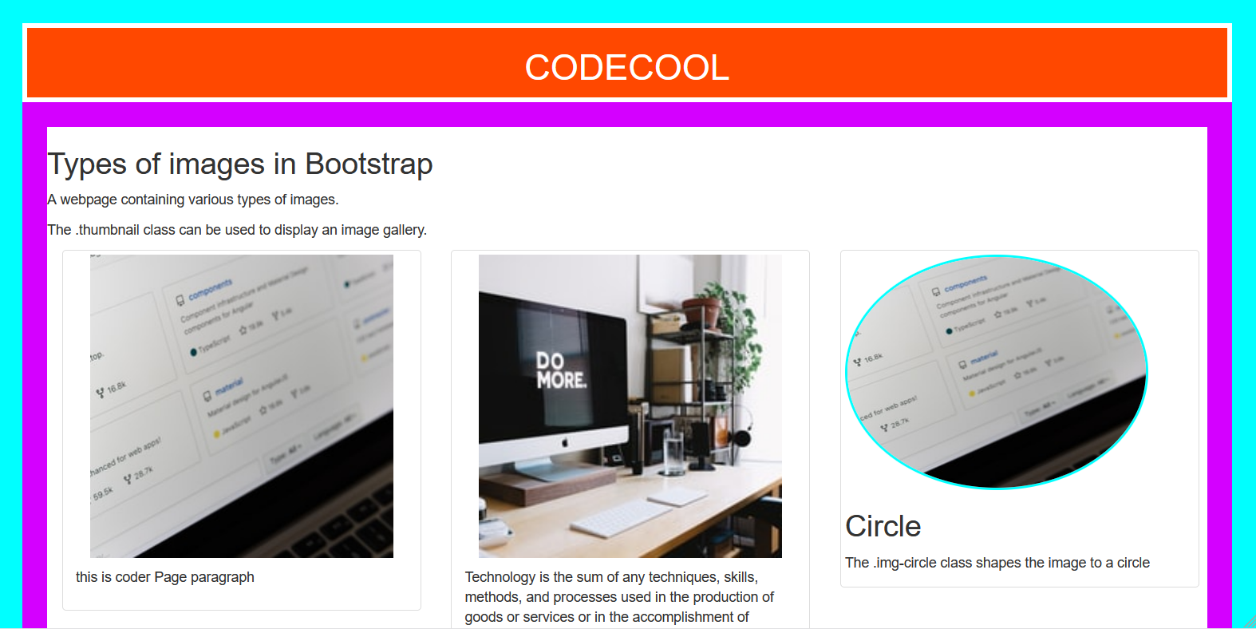

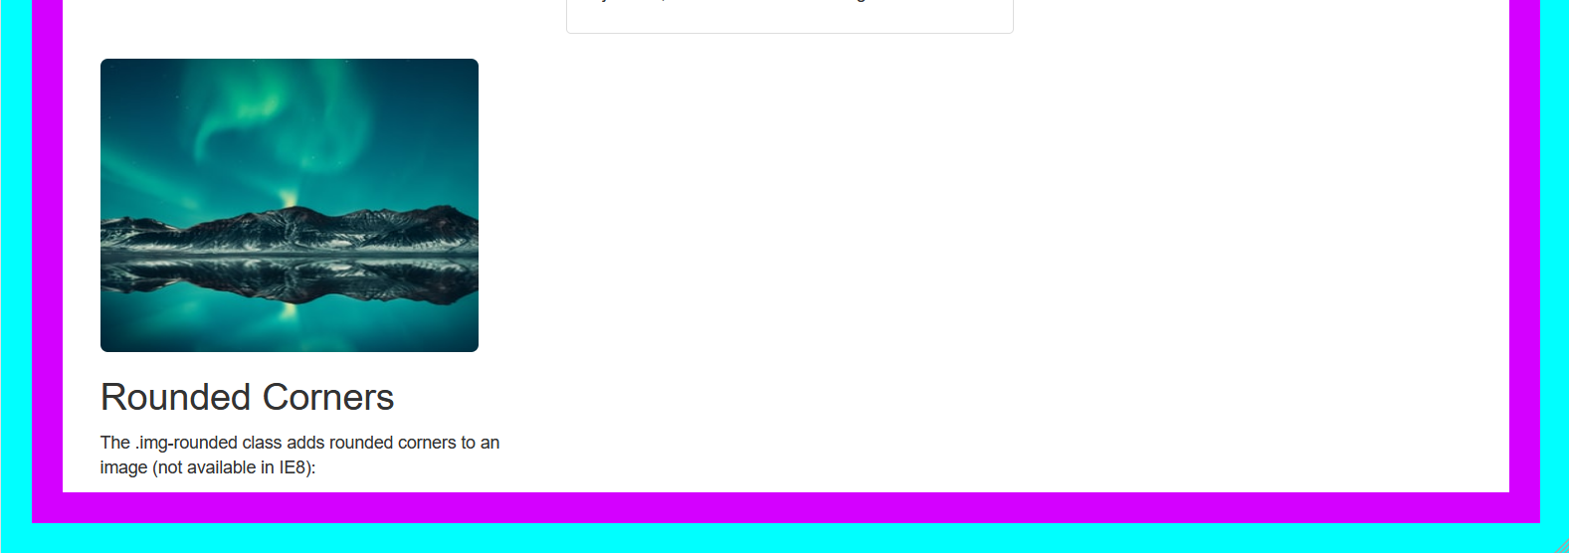

Practical-15

<!doctype html>

<html lang="en">

<head>

    <!-- Required meta tags -->

    <meta charset="utf-8">

    <meta name="viewport" content="width=device-width, initial-scale=1, shrink-to-fit=no">

    <!-- Bootstrap CSS -->

    <link rel="stylesheet" href="https://maxcdn.bootstrapcdn.com/bootstrap/4.0.0/css/bootstrap.min.css"

        integrity="sha384-Gn5384xqQ1aoWXA+058RXPxPg6fy4IWvTNh0E263XmFcJlSAwiGgFAW/dAiS6JXm" crossorigin="anonymous">

    <title>type of button</title>

    <style>

        .body{

            border: 25px solid cyan;

        }

    </style>

</head>

<body class="body">

    <div style="border: 25px solid rgb(123, 255, 0);">

    <div style="border: 4px solid white;cursor: copy; color: white; background-color: rgb(55, 41, 250);

    text-align: center;

    font-size: 2.3rem;

line-height: 1.3;

letter-spacing: 0.108em;

font-weight: 600;

font-style: italic;">

        <h1>CODE COOL</h1>

    </div>

    <h3>bootstrap Button types</h3>

    <button type="button" class="btn btn-primary">Primary</button>

    <button type="button" class="btn btn-secondary">Secondary</button>

    <button type="button" class="btn btn-success">Success</button>

    <button type="button" class="btn btn-danger">Danger</button>

<br><hr>

<h3>link button with Pages</h3>

    <a class="btn btn-primary" href="#" role="button">Link</a>

    <button class="btn btn-primary" type="submit">Button</button>

    <input class="btn btn-primary" type="button" value="Input">

    <input class="btn btn-primary" type="submit" value="Submit">

<br><hr>

<h3>Outline buttons</h3>

<button type="button" class="btn btn-outline-primary">Primary</button>

<button type="button" class="btn btn-outline-secondary">Secondary</button>

<button type="button" class="btn btn-outline-success">Success</button>

<button type="button" class="btn btn-outline-danger">Danger</button>

<button type="button" class="btn btn-outline-warning">Warning</button>

<br><hr>

<h3>Size of buttton</h3>

<button type="button" class="btn btn-primary btn-lg">Large button</button>

<button type="button" class="btn btn-success">Secondary</button>

<button type="button" class="btn btn-danger btn-sm">Small button</button>

<br>

<button type="button" class="btn btn-danger btn-lg btn-block">Block level button</button>

<br><hr>

<h3>Active state</h3>

<p>Buttons will appear pressed (with a darker background, darker border, and inset shadow) when active. There’s no need to add a class to <button>s as they use a pseudo-class. However, you can still force the same active appearance with .active (and include the aria-pressed="true" attribute) should you need to replicate the state programmatically.</p>

<a href="#" class="btn btn-primary btn-lg active" role="button" aria-pressed="true">Primary link</a>

<a href="#" class="btn btn-secondary btn-lg active" role="button" aria-pressed="true">Link</a>

<br><hr>

<div class="btn-group btn-group-toggle" data-toggle="buttons">

    <label class="btn btn-secondary active">

      <input type="radio" name="options" id="option1" autocomplete="off" checked> like

    </label>

    <label class="btn btn-secondary">

      <input type="radio" name="options" id="option2" autocomplete="off"> hello

    </label>

    <label class="btn btn-secondary">

      <input type="radio" name="options" id="option3" autocomplete="off"> Code

    </label>

  </div>

    <!-- Optional JavaScript -->

    <!-- jQuery first, then Popper.js, then Bootstrap JS -->

    <script src="https://code.jquery.com/jquery-3.2.1.slim.min.js"

        integrity="sha384-KJ3o2DKtIkvYIK3UENzmM7KCkRr/rE9/Qpg6aAZGJwFDMVNA/GpGFF93hXpG5KkN"

        crossorigin="anonymous"></script>

    <script src="https://cdnjs.cloudflare.com/ajax/libs/popper.js/1.12.9/umd/popper.min.js"

        integrity="sha384-ApNbgh9B+Y1QKtv3Rn7W3mgPxhU9K/ScQsAP7hUibX39j7fakFPskvXusvfa0b4Q"

        crossorigin="anonymous"></script>

    <script src="https://maxcdn.bootstrapcdn.com/bootstrap/4.0.0/js/bootstrap.min.js"

        integrity="sha384-JZR6Spejh4U02d8jOt6vLEHfe/JQGiRRSQQxSfFWpi1MquVdAyjUar5+76PVCmYl"

        crossorigin="anonymous"></script>

    </div>

</body>

</html>

***Website of P15***

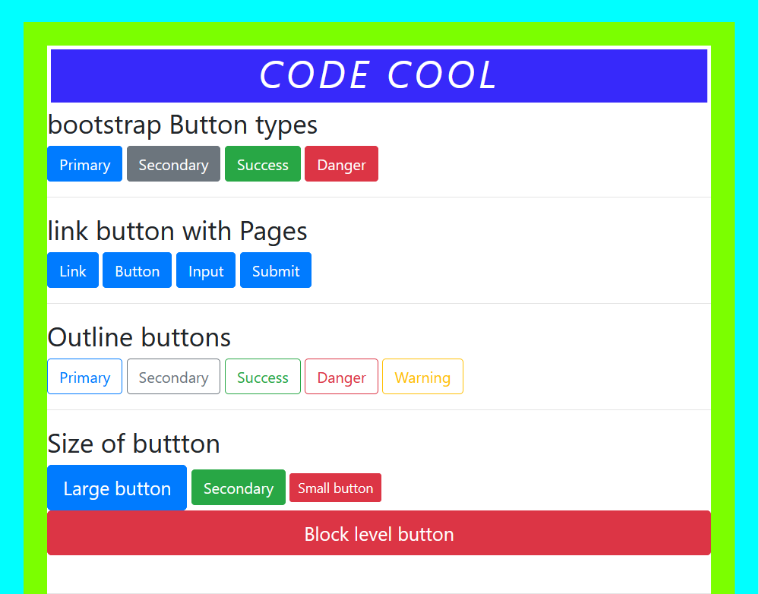

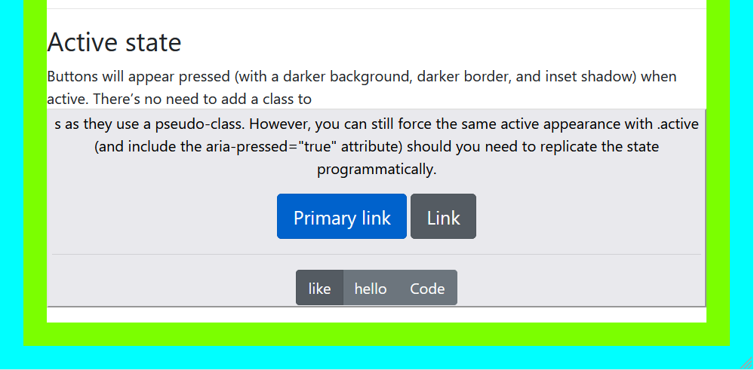

Practical-16

<!DOCTYPE html>

<html lang="en">

<head>

  <title>Bootstrap Example</title>

  <style>

      .body{

          background-image: url(/josh-bean-medium\ backgroundweb\ -9501ba9f.jpg);

          opacity: 1;

          text-align: center;

          color: white;

          padding: 0px;

      }

  </style>

  <meta charset="utf-8">

  <meta name="viewport" content="width=device-width, initial-scale=1">

  <link rel="stylesheet" href="https://maxcdn.bootstrapcdn.com/bootstrap/3.4.1/css/bootstrap.min.css">

  <script src="https://ajax.googleapis.com/ajax/libs/jquery/3.5.1/jquery.min.js"></script>

  <script src="https://maxcdn.bootstrapcdn.com/bootstrap/3.4.1/js/bootstrap.min.js"></script>

</head>

<body>

<div class="container body">

    <h1 style="color: blue; background-color: cyan; border: 4px solid white;border-radius: 5px;

     ">Code Cool</h1>

  <h2>Contextual Backgrounds</h2>

  <p>Use the contextual background classes to provide "meaning through colors":</p>

  <p class="bg-primary">This text is important.</p>

  <div style="color: rgb(54, 66, 241);" >

      <p class="bg-success">This text indicates success.</p>

      <p class="bg-danger">This text represents danger.</p>

  </div>

  <h1>Code cool (36px)</h1>

  <h5>h5 Code heading (14px)</h5>

  <h6>h6 code heading (12px)</h6>

  <h1>Lighter, Secondary Text</h1>

  <h1>h1 Hello <small>This is me</small></h1>

  <h2>h2 heading <small>secondary text</small></h2>

  <h1>Highlight Text of Para</h1>

  <p>Use the mark element to <mark>highlight on my text</mark> text.</p>

  <h1>Abbreviations</h1>

  <p>The abbr element is used to mark up an abbreviation or acronym:</p>

  <p>The <abbr title="World Health Organization">WHO(world Health Organization)</abbr> was founded in 1948.</p>

  <h1>Blockquotes</h1>

  <p>The blockquote element is used to present content from another source:</p>

  <blockquote>

    <p>For 50 years, WWF has been protecting the future of nature. The world's leading conservation organization, WWF works in 100 countries and is supported by 1.2 million members in the United States and close to 5 million globally.</p>

    <footer>From WWF's website</footer>

  </blockquote>

  <h1>Description Lists</h1>

  <p>The dl element indicates a description list:</p>

  <dl>

    <dt>created by</dt>

    <dd>            Shehbaz khan</dd>

    <dt>Milk</dt>

    <dd>- white cold drink i like it.</dd>

    <dt>We do code</dt>

    <dd>            for Do new thing's </dd></dl>     </div></body></html>

***Website of P16***

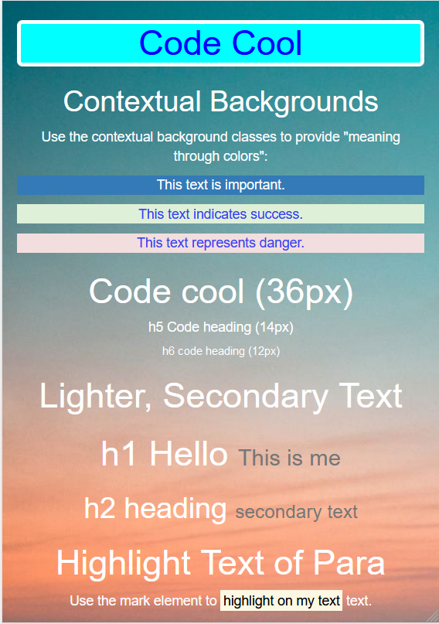

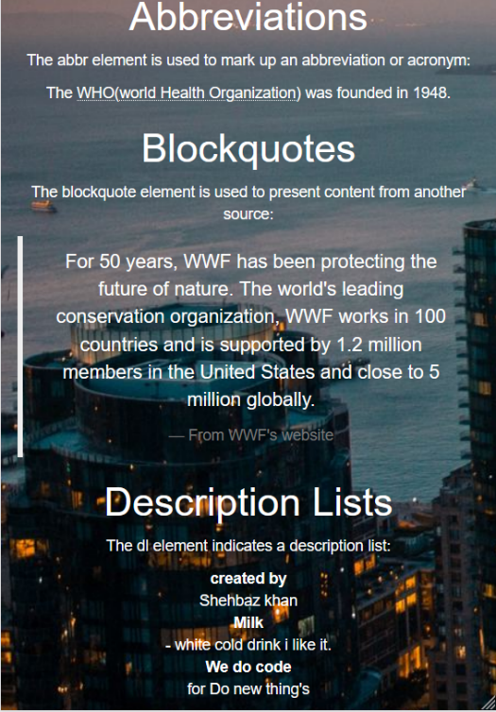

Practical-17

<!doctype html>

<html>

  <head>

    <!-- Required meta tags -->

    <meta charset="utf-8">

    <meta name="viewport" content="width=device-width, initial-scale=1">

    <!-- Bootstrap CSS -->

    <link href="https://cdn.jsdelivr.net/npm/bootstrap@5.1.3/dist/css/bootstrap.min.css" rel="stylesheet" integrity="sha384-1BmE4kWBq78iYhFldvKuhfTAU6auU8tT94WrHftjDbrCEXSU1oBoqyl2QvZ6jIW3" crossorigin="anonymous">

    <link rel="stylesheet" href="https://maxcdn.bootstrapcdn.com/bootstrap/3.3.6/css/bootstrap.min.css">

        <script src="https://ajax.googleapis.com/ajax/libs/jquery/1.12.0/jquery.min.js">

        </script>

        <script src="https://maxcdn.bootstrapcdn.com/bootstrap/3.3.6/js/bootstrap.min.js">

        </script>

    <style>

        .body{

            margin-top: 4px;

            padding: 0px;

        }

    </style>

    <title>Hello, world!</title>

  </head>

  <body>

      <footer>

          <div class="container">

              <div class="jumbotron" style="background-color: rgb(206, 203, 200);">

                <h1 class="display-4" style="padding-top: 10px; font-size: 36px;

          line-height: 0.5;

          letter-spacing: 0.005em;

          font-weight: 500;

          font-style: normal;">Read more info for c language</h1>

          <p class="lead">C Keywords and Identifiers

            In this tutorial, you will learn about keywords; reserved words in C programming that are part of the syntax. Also, you will learn about identifiers and how to name them.

            Character set

            A character set is a set of alphabets, letters and some special characters that are valid in C language.

            Alphabets

            Uppercase: A B C ................................... X Y Z

            Lowercase: a b c ...................................... x y z

            Also remember, identifier names must be different from keywords. You cannot use int as an identifier

            because int is a keyword.</p>

            <p>It uses utility classes for typography and spacing to space content out within the larger container.</p>

            <a class="btn btn-primary btn-lg" href="#" role="button">Learn more</a>

            <div class="container">

              <hr class="my-4">

              <br>

            <h1>Bootstrap Glyphicons</h1>

            <p>

                Here are some glyphicons examples

                which shows different icons:-

            </p>

            <p>Home Icon along with button

                <button type="button" class="btn btn-success">

                    <span class="glyphicon glyphicon-home"></span> Home

                </button>

            </p>

            <p> user icons

                <button type="button" class="btn btn-danger">

                    <span class="glyphicon glyphicon-user"></span> user

                </button>

            </p>

            <p> user icons Heat you like this click

                <button type="button" class="btn btn-primary">

                    <span class="glyphicon glyphicon-heart-empty"></span> Heart

                </button>

            </p>

            <p> All document download from here

                <button type="button" class="btn btn-info">

                    <span class="glyphicon glyphicon-save"></span> download

                </button>

            </p>

            <p>Home Icon along with button

                <button type="button" class="btn btn-danger">

                    <span class="glyphicon glyphicon-lock"></span> Lock i

                </button>

            </p>

            <p>Search Icon along with button

                <button type="button" class="btn btn-primary">

                    <span class="glyphicon glyphicon-search"></span> Search

                </button>

            </p>

            <p> you want to funding on my start-up

                <button type="button" class="btn btn-warning">

                    <span class="glyphicon glyphicon-piggy-bank"></span> Funding in start-up

                </button>

            </p>

        </div>

          <p>It uses utility classes for typography and spacing to space content out within the larger container.</p>

          <a class="btn btn-primary btn-lg" href="#" role="button">Learn more</a>

        </div>

    </div>

</footer>

    <!-- Option 1: Bootstrap Bundle with Popper -->

    <script src="https://cdn.jsdelivr.net/npm/bootstrap@5.1.3/dist/js/bootstrap.bundle.min.js" integrity="sha384-ka7Sk0Gln4gmtz2MlQnikT1wXgYsOg+OMhuP+IlRH9sENBO0LRn5q+8nbTov4+1p" crossorigin="anonymous"></script>

  </body>

</html>

***Website of P17***

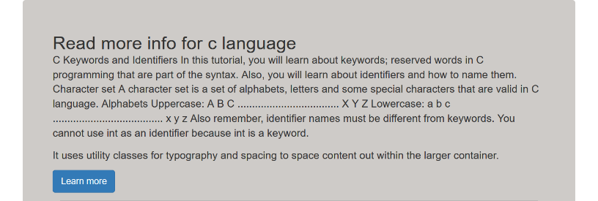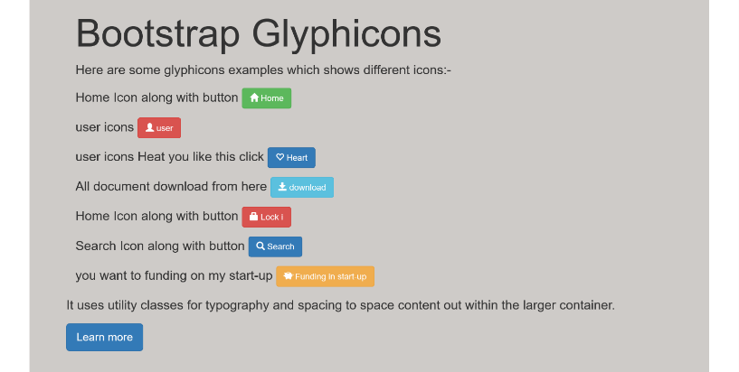

Practical-18

<html>

   <head>

      <script type = "text/javascript">

            function Warn() {

               alert ("This is a warning message!");

               document.write ("This is a warning message!");

               document.write ("Write a program to show the usage of inbuilt functions and dialog boxes");

            }

      </script>

      <style>

         .body{

            background-image: url(/HONG_KONG_-_0915_-_Libertà-web\ Baground.jpg);

            color: white;

         }

      </style>

      <style>

         /* unvisited link */

         a:link {

           color: rgb(8, 250, 8);

         }

         /* visited link */

         a:visited {

           color: rgb(198, 252, 6);

         }

         /* mouse over link */

         a:hover {

           color: red;

         }

         /* selected link */

         a:active {

           color: yellow;

         }

         </style>

      <meta charset="utf-8">

    <meta name="viewport" content="width=device-width, initial-scale=1, shrink-to-fit=no">

    <!-- Bootstrap CSS -->

    <link rel="stylesheet" href="https://maxcdn.bootstrapcdn.com/bootstrap/4.0.0/css/bootstrap.min.css" integrity="sha384-Gn5384xqQ1aoWXA+058RXPxPg6fy4IWvTNh0E263XmFcJlSAwiGgFAW/dAiS6JXm" crossorigin="anonymous">

    <title>Hello, world!</title>

   </head>

   <body class="body">

      <h1>Go to home Page: <a href="index.html">CODE COOL</a></h1>

     <h1> Artificial Intelligence in information technology  </h1>

      <p>   AI for IT operations refers to the use of Artificial Intelligence to manage Information Technology

         Content of Paragraph

</p>

      <form>

         <input type = "button" value = "Click Me" onclick = "Warn();" style="background-color: rgb(255, 94, 0);font-size: 20px; margin: 5px;border: 2px solid rgb(0, 255, 76);color: white; border-radius: 4px;" />

         <button type="button" class="btn btn-outline-warning" onclick = "Warn();" value = "Click Me">Warning</button>

      </form>

   </body>

***Website of P18***





Practical-19

<html>

  <meta charset="utf-8">

  <meta name="viewport" content="width=device-width, initial-scale=1">

  <link rel="stylesheet" href="https://maxcdn.bootstrapcdn.com/bootstrap/3.4.1/css/bootstrap.min.css">

  <script src="https://ajax.googleapis.com/ajax/libs/jquery/3.5.1/jquery.min.js"></script>

  <script src="https://maxcdn.bootstrapcdn.com/bootstrap/3.4.1/js/bootstrap.min.js"></script>

<body>

<h1 style="border: 3px solid white; text-align: center; color: white;background-color: cyan"><b>CODE COOL</b></h1>

<h2>JavaScript Alert</h2>

<p>Alert Box is used to show message in a dialog box on clicking button</p>

<!-- <button onclick="myFunction()">Click ON Me!</button> -->

<button onclick="myFunction()" type="button" class="btn btn-warning" >Click ON Me!</button>

<script>

function myFunction() {

  alert("This is an alert box!");

  alert("This is an alert box!");

  alert("This is an alert box!");

  alert("This is an alert box!");

}

</script>

<h2>JavaScript Confirm Box</h2>

<button onclick="myFunction1()" type="button" class="btn btn-danger" >Confirm?</button>

<!-- <button onclick="myFunction1()">Confirm?</button> -->

<p>Confirm box is used to get different inputs from user through dialog box</p>

<p id="demo1"></p>

<script>

function myFunction1() {

  var age =prompt("What is your age? for show this web");

  var txt;

  if (confirm("Press a button!")) {

    txt = "You pressed OK! well done we do code to Make new Things Ai ML ";

  } else {

    txt = "You pressed Cancel! you not confirm? it";

  }

  document.getElementById("demo1").innerHTML = txt;

}

</script>

</body>

</html>

***Website of P19***

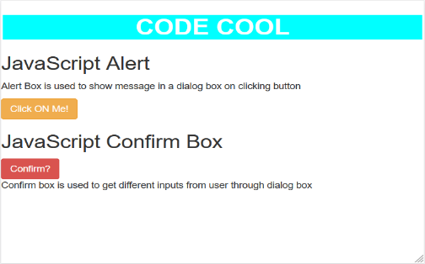

***Practical-20***

Source code:

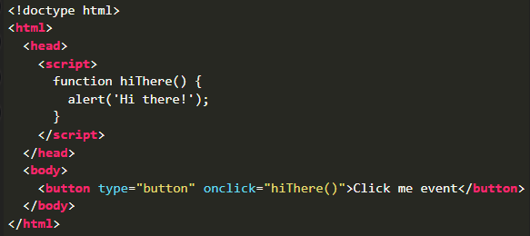

**output**



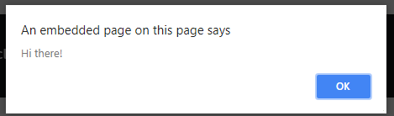

Practical-21

<!DOCTYPE html>

<html lang="en">

<head>

    <title>Testing JS </title>

    <style>

        p{

            background-color: rgb(255, 123, 0);

        }

    </style>

    <!-- <script type="text/javascript">

        // document.write("hello world");

        //Author : SHEHBAZ

    </script> -->

</head>

<body>

    <div style="border: 25px solid rgb(123, 255, 0);">

        <div style="border: 4px solid white;cursor: copy; color: white; background-color: rgb(55, 41, 250);

 text-align: center; font-size: 1.1rem; line-height: 0.3; letter-spacing: 0.033em; font-weight: 600; font-style: italic;">

            <h1>CODE COOL</h1>

        </div>

        <div style="border: 25px solid cyan;">

        <h1>javascript Page</h1>

        <p id="th">Machine learning (ML) is the study of computer algorithms that can improve automatically through experience and by the use of data.[1] It is seen as a part of artificial intelligence.

</p>

        <script src="index.js"></script>

        <br>

        <script src="post.js"></script>

        <br>

        <script type="text/javascript">

            let date = new Date();

            document.write(date, "<br>");

        // alert("this is Error");

        </script>

        </div>

</body>

</html>

Javascript file Code(post.js):-

// program to find Power and sqrt

alert("This is an alert message box.");  // display string message

var num1 = prompt("Enter your number we give you power of a given number ")

var num2 = prompt("power of number ")

document.write("your number is  ",num1,"<br>");

document.write("your power of a number  ",num2,"<br>");

document.write("this is Power value ",Math.pow(num1,num2),"<br>");

document.write("sqrt is num1 is ",Math.sqrt(num1),"<br>");

document.write("sqrt is num2 is ",Math.sqrt(num2),"<br>");

var age =prompt("What is your age? ");

switch (age) {

    case "22":

        document.write("your Age is 22 you Do every thing what ever you want");

        break;

    case "12":

        document.write("your Age is 12");

        break;

    case "18":

        document.write("your Age is 18 you are teenagers");

        break;

    case "34":

        document.write("your Age is 34");

        break;

    default:

        document.write("**your Age is default (killer performance)**)")

        document.write("Do that Thing that make you Happy.")

        break;

***Website of P21***

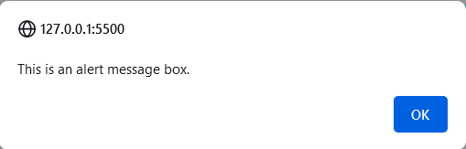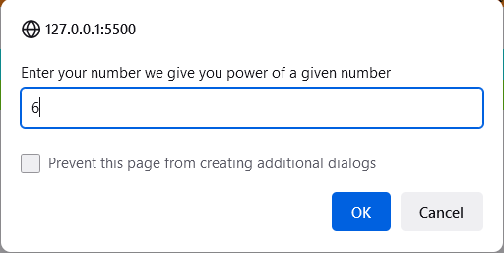

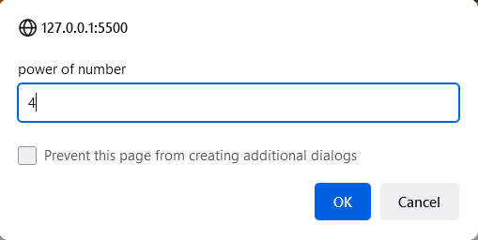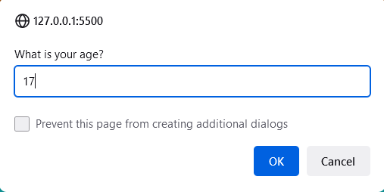

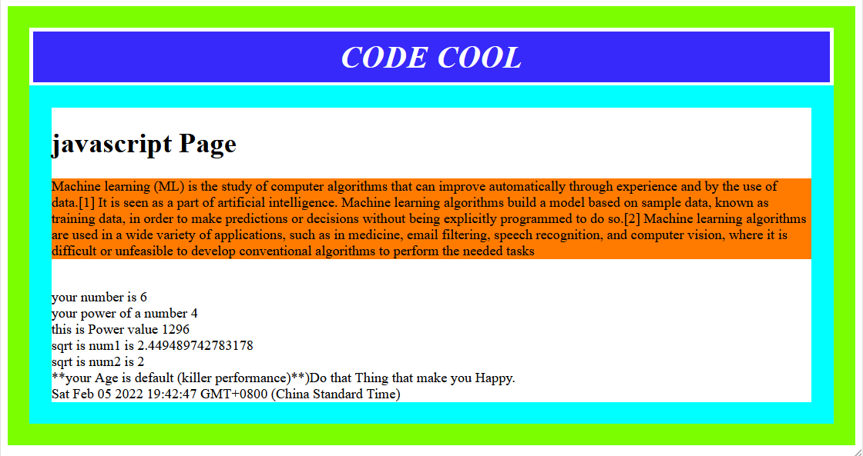

Practical 22

WAP to display the bookstore details in XML with CSS and internal DTD.

Source code:

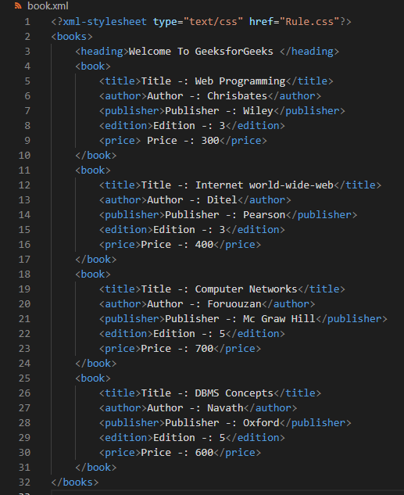

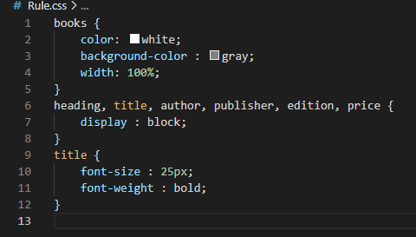

**output:**

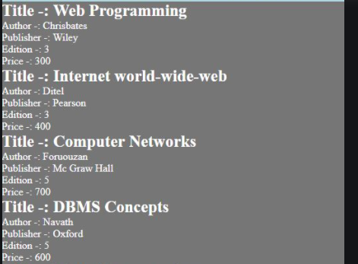

Practical 23:

WAP to format the Teacher details in XML with CSS using external DTD.

source code:

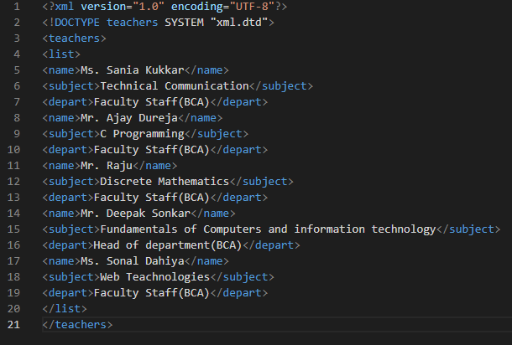

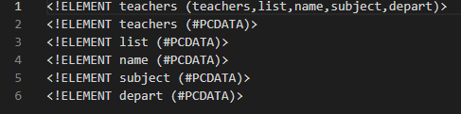

**output:**

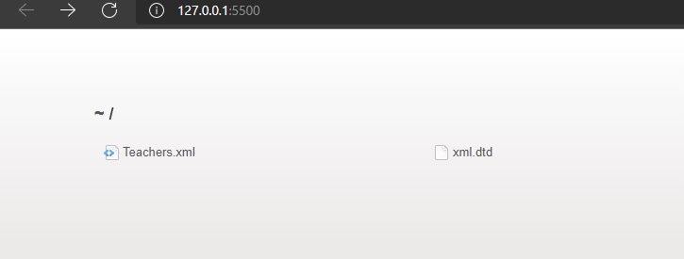

Practical:- 25

Create a webpage with :

1. Three Equal Responsive columns
2. Three Unequal Responsive columns

______________________Three Equal Responsive columns________

***Webpage***

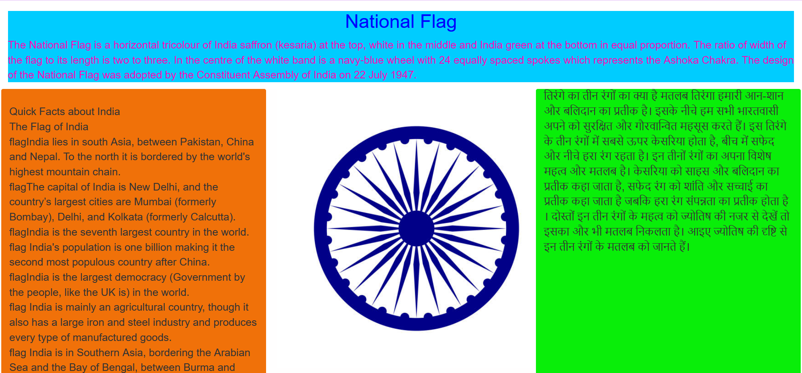

|  |
| --- |
|  |

__________________Three Unequal Responsive columns___________

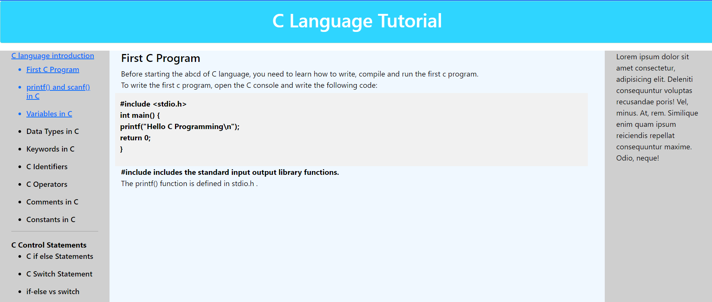

Practical:- 26

Design the registration form for a web site and when the user clicks on submit button

the login form should be appeared on the screen (use external javascript file).

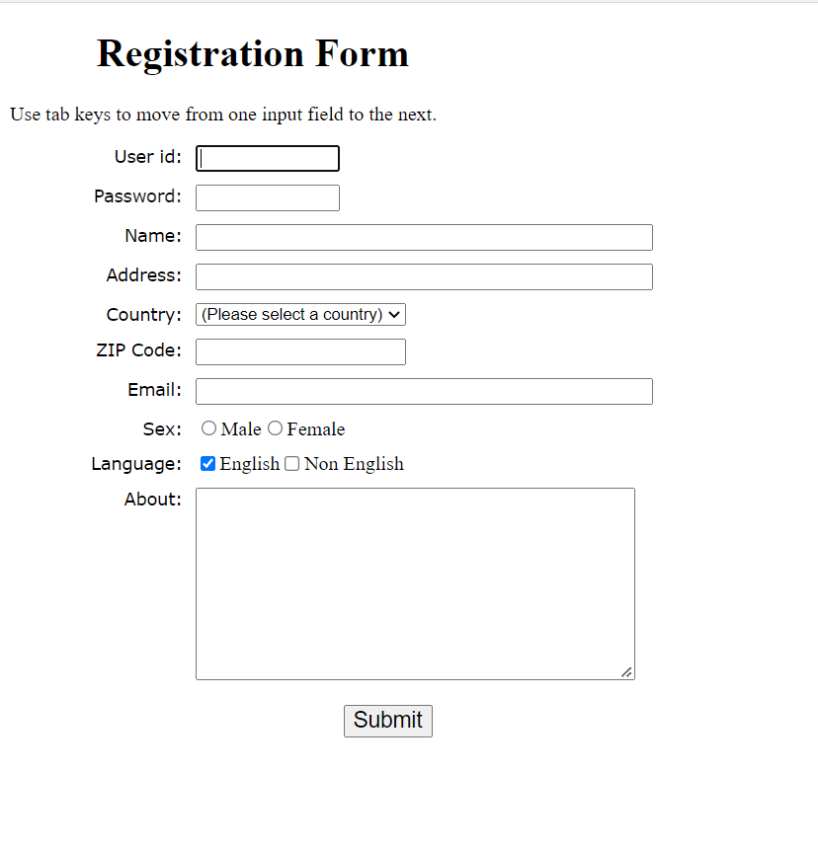

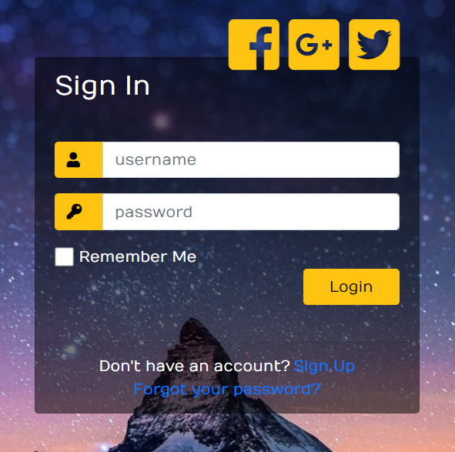

Practical:- 27

Create a Zebra-striped Tables: Setting different background colors for alternate rows

is a popular technique to improve the readability of tables that has large amount of

data. This is commonly known as zebra-striping a table. Make use of pseudo classes

to create zebra stripped Table.

<!doctype html>

<html lang="en">

  <head>

    <!-- Required meta tags -->

    <meta charset="utf-8">

    <meta name="viewport" content="width=device-width, initial-scale=1, shrink-to-fit=no">

    <!-- Bootstrap CSS -->

    <link rel="stylesheet" href="https://cdn.jsdelivr.net/npm/bootstrap@4.1.3/dist/css/bootstrap.min.css" integrity="sha384-MCw98/SFnGE8fJT3GXwEOngsV7Zt27NXFoaoApmYm81iuXoPkFOJwJ8ERdknLPMO" crossorigin="anonymous">

    <title>Zebra-striped Table</title>

  </head>

  <body>

   <h1>Zebra-striped Table</h1>

    <table class="table table-hover">

        <thead>

            <tr style="text-align: center;">

                <th colspan = "6" class="bg-danger">Employee details</th>

                </tr>

           <tr>

          <th class="table-primary dark">Emp_No</th>

          <th class="table-primary">Emp_name</th>

          <th class="table-primary">JOB</th>

          <th class="table-primary">HireDate</th>

          <th class="table-primary">SAl</th>

          <th class="table-primary">Dep_name</th>

        </tr>

        </thead>

        <tbody>

          <tr>

            <td class="table-primary">1101</td>

            <td class="table-secondary">Shehbaz</td>

            <td class="table-success">Manager</td>

            <td class="table-warning">2-sep-2022</td>

            <td class="table-info">1999</td>

            <td class="table-success">IT dept</td>

          </tr>

          <tr>

            <td class="table-primary">1101</td>

            <td class="table-secondary">Shehbaz khan</td>

            <td class="table-success">Saleman</td>

            <td class="table-warning">16-jan-2022</td>

            <td class="table-info">1229</td>

            <td class="table-success">AI Power</td>

          </tr>

          <tr>

            <td class="table-primary">1101</td>

            <td class="table-secondary">John Abraham </td>

            <td class="table-success">Manager</td>

            <td class="table-warning">2-sep-2022</td>

            <td class="table-info">1999</td>

            <td class="table-success">RAW</td>

          </tr>

          <tr>

            <td class="table-primary">1101</td>

            <td class="table-secondary">Kunal</td>

            <td class="table-success">head</td>

            <td class="table-warning">19-Mar-2022</td>

            <td class="table-info">1999</td>

            <td class="table-success">ML dept</td>

          </tr>

          <tr>

            <td class="table-primary">1101</td>

            <td class="table-secondary">Shehbaz**</td>

            <td class="table-success">CIA agent</td>

            <td class="table-warning">21-jul-2022</td>

            <td class="table-info">1999</td>

            <td class="table-success">Ai </td>

          </tr>

        </tbody>

      </table>

    <!-- Optional JavaScript -->

    <!-- jQuery first, then Popper.js, then Bootstrap JS -->

    <script src="https://code.jquery.com/jquery-3.3.1.slim.min.js" integrity="sha384-q8i/X+965DzO0rT7abK41JStQIAqVgRVzpbzo5smXKp4YfRvH+8abtTE1Pi6jizo" crossorigin="anonymous"></script>

    <script src="https://cdn.jsdelivr.net/npm/popper.js@1.14.3/dist/umd/popper.min.js" integrity="sha384-ZMP7rVo3mIykV+2+9J3UJ46jBk0WLaUAdn689aCwoqbBJiSnjAK/l8WvCWPIPm49" crossorigin="anonymous"></script>

    <script src="https://cdn.jsdelivr.net/npm/bootstrap@4.1.3/dist/js/bootstrap.min.js" integrity="sha384-ChfqqxuZUCnJSK3+MXmPNIyE6ZbWh2IMqE241rYiqJxyMiZ6OW/JmZQ5stwEULTy" crossorigin="anonymous"></script>

  </body>

</html>

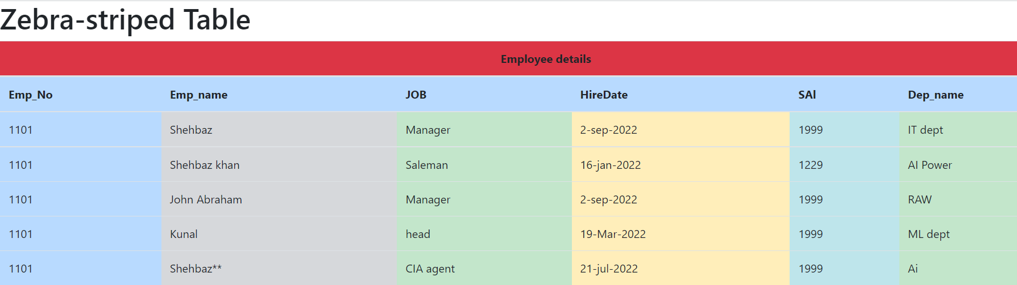

Practical:-28.

Create a Questionnaire related to any topic of your choice by using Form Elements.

<html><head>

<meta charset="UTF-8">

<meta http-equiv="X-UA-Compatible" content="IE=edge">

<meta name="viewport" content="width=device-width, initial-scale=1.0">

<title>

Questionnare Page

</title>

<style>

body {

background-color: #6bf5f5;

font-family: Verdana;

text-align: center;

}

form {

background-color: #fff;

max-width: 500px;

margin: 50px auto;

padding: 30px 20px;

box-shadow: 2px 5px 10px rgba(0, 0, 0, 0.5);

}

.form-control {

            text-align: left;

            margin-bottom: 25px;

        }

        .form-control label {

            display: block;

            margin-bottom: 10px;

        }

        .form-control input,

        .form-control select,

        .form-control textarea {

            border: 1px solid #777;

            border-radius: 2px;

            font-family: inherit;

            padding: 10px;

            display: block;

            width: 95%;

        }

        .form-control input[type="radio"],

        .form-control input[type="checkbox"] {

            display: inline-block;

            width: auto;

        }

        button {

            background-color: #4dc6ff;

            border: 1px solid rgb(255, 255, 255);

            border-radius: 2px;

            font-family: inherit;

            font-size: 21px;

            display: block;

            width: 50%;

            margin-top: 50px;

            margin-bottom: 20px;

        }

    </style>

</head>

<body>

    <h1>Questionnare Form</h1>

    <form id="form">

        <div class="form-control">

            <label for="name" id="label-name">

                Name

            </label>

            <input type="text" id="name" placeholder="Enter your name" />

        </div>

        <div class="form-control">

            <label for="email" id="label-email">

                Email

            </label>

            <input type="email" id="email" placeholder="Enter your email" />

        </div>

        <div class="form-control">

            <label for="age" id="label-age">

                Age

            </label>

            <input type="text" id="age" placeholder="Enter your age" />

        </div>

        <div class="form-control">

            <label for="role" id="label-role">

                Which option best describes you?

            </label>

            <select name="role" id="role">

                <option value="student">Student</option>

                <option value="intern">Intern</option>

                <option value="professional">

                    Professional

                </option>

                <option value="other">Other</option>

            </select>

        </div>

        <div class="form-control">

            <label>

                Would you recommed Learning

                computer language to a friend?

            </label>

            <label for="recommed-1">

                <input type="radio"

                    id="recommed-1"

                    name="recommed">Yes</input>

            </label>

            <label for="recommed-2">

                <input type="radio"

                    id="recommed-2"

                    name="recommed">No</input>

            </label>

            <label for="recommed-3">

                <input type="radio"

                    id="recommed-3"

                    name="recommed">Maybe</input>

            </label>

        </div>

        <div class="form-control">

            <label>Languages and Frameworks known

                <small>(Check all that apply)</small>

            </label>

            <label for="inp-1">

                <input type="checkbox"

                    name="inp">C</input></label>

            <label for="inp-2">

                <input type="checkbox"

                    name="inp">C++</input></label>

            <label for="inp-3">

                <input type="checkbox"

                    name="inp">C#</input></label>

            <label for="inp-4">

                <input type="checkbox"

                    name="inp">Java</input></label>

            <label for="inp-5">

                <input type="checkbox"

                    name="inp">Python</input></label>

            <label for="inp-7">

                <input type="checkbox"

                    name="inp">Django</input></label>

            <label for="inp-7">

                <input type="checkbox"

                    name="inp">Spring</input></label>

        </div>

        <div class="form-control">

            <label for="comment">

                Any comments or suggestions

            </label>

            <textarea name="comment" id="comment"

                placeholder="Enter your comment here">

            </textarea>

        </div>

        <button type="submit" value="submit">

            Submit

        </button>

    </form>

</body>

</html>

Questionnaire Form

